DISCLAIMER: THIS IS AN EXAMPLE SSP REPORT – CALCULATIONS ARE NOT ACCURATE. THIS IS JUST MEANT TO PROVIDE AN EXAMPLE OF WHAT A COMPLETE SSP MIGHT LOOK LIKE

Stormwater Site Plan (SSP) Report
Coldest Ice Convenience Store

Prepared For
SDEV21-210X and WO21-210Y
Project Location
7801 S. Sheridan
6640001161

Stormwater Site Plan Prepared By
Name | Organization | Contact Telephone Number | Email Address
Awesome Engineer | Engineer, Inc. | 253-123-1234 | awesomeengineer@engineerinc.com

Date Prepared
05/04/2021

I hereby certify that this Amazingly Perfect Stormwater Site Plan was prepared by me or under my direct supervision. Blah, blah, blah, 12345 RCW. Etc. etc. etc. WAC 12.34.56X

Table of Contents

1. Project Information 5
2. Project Overview 6
3. Existing Project Site Conditions 7
4. Proposed Project Site Conditions 13
5. Minimum Requirement Determination 16
6. Discussion of Minimum Requirements 21
A. Minimum Requirement #1 – Preparation of a Stormwater Site Plan 21
B. Minimum Requirement #2 – Construction Stormwater Pollution Prevention Plan 21
C. Minimum Requirement #3 – Source Control 22
D. Minimum Requirement #4 – Preserving Drainage Patterns and Outfalls 23
E. Minimum Requirement #5 – Onsite Stormwater Management 24
F. Minimum Requirement #6 – Stormwater Treatment 26
G. Minimum Requirement #7 – Flow Control 28
H. Minimum Requirement #8 – Wetlands Protection 30
I. Minimum Requirement #9 – Operation and Maintenance 30
7. Additional Protective Measure – Infrastructure Protection 31
8. Conveyance System Design 31
Appendices 32
A. Minimum Requirement #5 – Infeasibility Checklists 32
City of Tacoma Stormwater Management Manual – Infeasibility Checklist 32
Surface Type: Roofs 32
Version: 07/01/2021 32
City of Tacoma Stormwater Management Manual – Infeasibility Checklist 33
Surface Type: Roofs or Other Hard Surface 33
BMP L630: Bioretention 33
Version: 07/01/2021 33
City of Tacoma Stormwater Management Manual – Infeasibility Checklist 36
Surface Type: Roofs and Other Hard Surfaces 36
Version: 07/01/2021 36
City of Tacoma Stormwater Management Manual – Infeasibility Checklist 37
Surface Type: Roofs 37
Version: 07/01/2021 37
City of Tacoma Stormwater Management Manual – Infeasibility Checklist 38
Surface Type: Roofs 38
Version: 07/01/2021 38
City of Tacoma Stormwater Management Manual – Infeasibility Checklist 40
Surface Type: Other Hard Surface 40
BMP L633: Permeable Pavement 40
Version: 07/01/2021 40
B. Soils Report 44
C. Stormwater Treatment Calculations 45
D. Conveyance System Design 71
E. Emerging Technology Use Level Designations 86

List of Figures

Figure 1 – Existing Site Use | 10
Figure 2 – Existing Condition Basin Map | 11
Figure 3 – Downstream Flowpath | 12
Figure 4 – Example Proposed Project Site Condition Map | 14
Figure 5 – All Projects and New Development Flowchart | 19
Figure 6 – Redevelopment Flowchart | 20
Figure 7 – Flowpath Lengths – Dispersion BMPs | 25
Figure 8 – Stormwater Treatment Basin | 27
Figure 9 – Flow Control Basin Map | 29

List of Tables
Table 1 – Project Thresholds | 16
Table 2 – Receiving Waterbody Table | 17
Table 3 – Minimum Requirement Table | 17
Table 4 – Source Control BMPs | 22

Notes for Preparer:
When completing the Stormwater Site Plan Report provide all required information in the textbox forms under each section and delete any sections from the report and appendices that are not applicable to the proposed project. Further information and guidance on the information required can be found in the comment bubbles to the right of each section. Once the report has been completed delete all comment bubbles and grey highlighted instructions, select the References tab and update the Table of Contents, and input the figure/table numbers and names in List of Figures and List of Tables under the contents page above.

Project Information
- Project Contacts
See Title Page for Stormwater Site Plan Development Team
- Property Owner
Name | Organization | Mailing Address | Contact Telephone Number | Email Address
Penny Frogmore | None | 1234 Frogmore Place, Britain, UK | 123456789 | pfrogmore@frogmore.com

- Applicant (if different than Property Owner)
Name | Organization | Mailing Address | Contact Telephone Number | Email Address
Alice Construction | Construction Org | 4321 Workplace Avenue | 987654321 | aconstr@const.com

- Associated Permits
- See Title Page for City of Tacoma Permit Numbers
- Associated City of Tacoma Permit Number(s)
None
- Other Federal, State, or Local Associated Permit Types and Numbers
None
- Vesting
- City of Tacoma Stormwater Management Manual Edition Used
2021 Stormwater Management Manual (SWMM)
- If using a manual other than the most current version, provide vesting justification:
NA

Project Overview

- Provide a brief description of the proposed project.
This project will construct a convenience store on a currently vacant lot. Improvements will include the construction of the convenience store and associated parking lot and all associated above and below ground utilities.

Existing Project Site Conditions

- Answer the following questions, provide additional description, and provide figures (if necessary) to describe the existing site conditions.

- Describe in one or two sentences the existing project site use:
The existing site use is a vacant lot with a mix of gravel and vegetation.
- Describe in words or show on a figure the stormwater runoff patterns (natural and artificial) and the points where stormwater enters and exits the project site.
Stormwater follows contours and generally flows from west to east where it enters the City of Tacoma stormwater system.
- Answer the following questions to help describe the existing site conditions. If Answer is Yes, include an associated figure(s) that shows location. Answers must be based upon site reconnaissance and readily available mapping data. See SWMM – Volume 2, Chapter 3 for resources.

Questions | Answer | Data Source(s)
Are groundwater protection areas located on the project site or within 500 feet of the project site? | ☐Yes  ☒No  ☐Unknown | Aquifer Recharge Areas (Pierce County) tMap Layer
Are wetlands and/or their buffers located on the project site or within 500 feet of the project site? | ☐Yes  ☒No  ☐Unknown | Wetland Inventory (Tacoma PDS) tMap Layer.
Are steep slopes located on the project site or within 500 feet of the project site? | ☐Yes  ☒No  ☐Unknown | tMap Layer  - Landslide Hazard Areas.  - Contours
Are floodplains located on the project site or within 500 feet of the project site? | ☐Yes  ☒No  ☐Unknown | Flooding Layers – tMap Layer.
Are streams located on the project site or within 500 feet of the project site? | ☐Yes  ☒No  ☐Unknown | Streams Layer (Pierce County) – tMap
Are creeks located on the project site or within 500 feet of the project site? | ☐Yes  ☒No  ☐Unknown | Waterbodies Layer (Pierce County) – tMap
Are ravines located on the project site or within 500 feet of the project site? | ☐Yes  ☒No  ☐Unknown | tMap Layers:  - Landslide Hazard Areas  - Contours  - Streams Layer (Pierce County)
Are springs located on the project site or within 500 feet of the project site? | ☐Yes  ☒No  ☐Unknown | - Landslide Hazard Areas (Pierce County)  - Streams (Pierce County)?
Are any other sensitive areas or critical areas located on the project site or within 500 feet of the project site? | ☐Yes  ☒No  ☐Unknown | tMap Layers:  - Aquifer Recharge Areas (Pierce County)  - Biodiversity Corridors (Tacoma)  - Landslide Hazard Areas (Pierce County)  - Liquifaction Susceptibility (WADNR)  - Mine Hazard Areas (Tacoma)  - Non-Wetland/No Stream (Tacoma PDS)  - Streams (Pierce County)  - Wetland Inventory (Tacoma PDS)
Are any structures located on the project site? | ☒Yes  ☐No  ☐Unknown
Are any fuel tanks or other storage tanks (above or below-ground) located on the project site? | ☐Yes  ☒No  ☐Unknown | tMap Layers:  - Regulated USTs and Active Facilities (Ecology)  - Regulated USTs and Inactive Facilities (Ecology)
Are any groundwater wells located on the project site or within 100 feet of the project site? | ☐Yes  ☒No  ☐Unknown | Source Water Assessment Program (SWAP) Map
Are any septic systems located on the project site or within 100 feet of the project site? | ☐Yes  ☒No  ☐Unknown | Sewer Cards
Are any Superfund sites located on the project site or within 100 feet of the project site? | ☐Yes  ☒No  ☐Unknown | Cleanups in My Community v1.0 tmap layer.
Are any Flood Hazard Areas located on the project site or within 100 feet of the project site? | ☐Yes  ☒No  ☐Unknown | Flooding Layers tMap layer.
Is the project located in the South Tacoma Groundwater Protection District? | ☒Yes  ☐No  ☐Unknown | Land Use – Zoning District 1 – tMap Layer.
Are any public or private easements located on the project site? | ☐Yes  ☒No  ☐Unknown | - Plat and Legal – Easements – tMap layer.  - Pierce County Assessor Parcel Search

- Additional Information
Figure 1 – Existing Site Use only shows the legend for items that were present on or near the site. See tMap for all other relevant legend items as necessary. Project has only one Threshold Discharge Area.

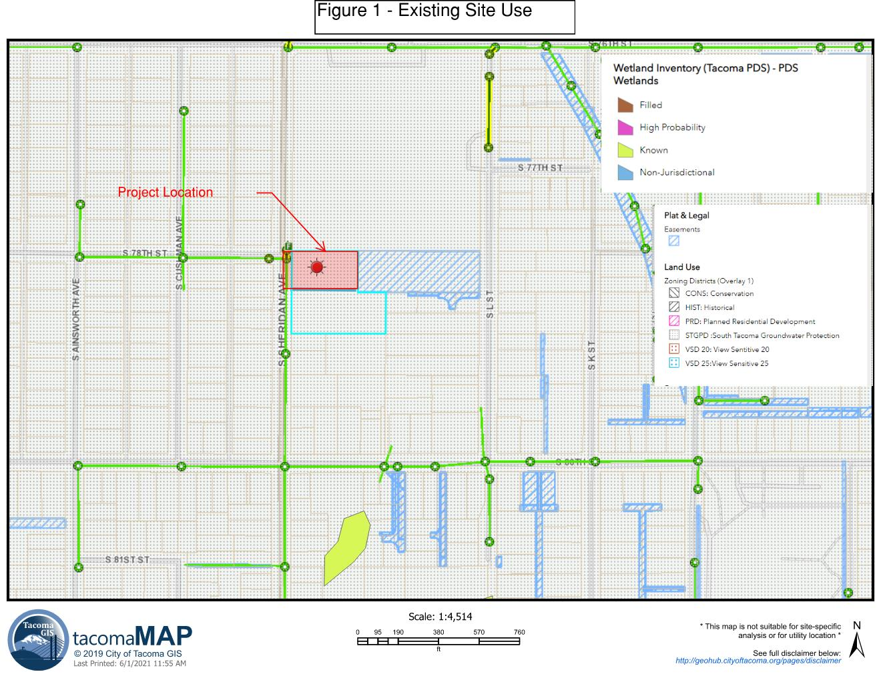
- Existing Project Site Condition Basin Map
Figure 2 – Existing Condition Basin Map
Red Area is existing hard surface area. Green is existing vegetation area.
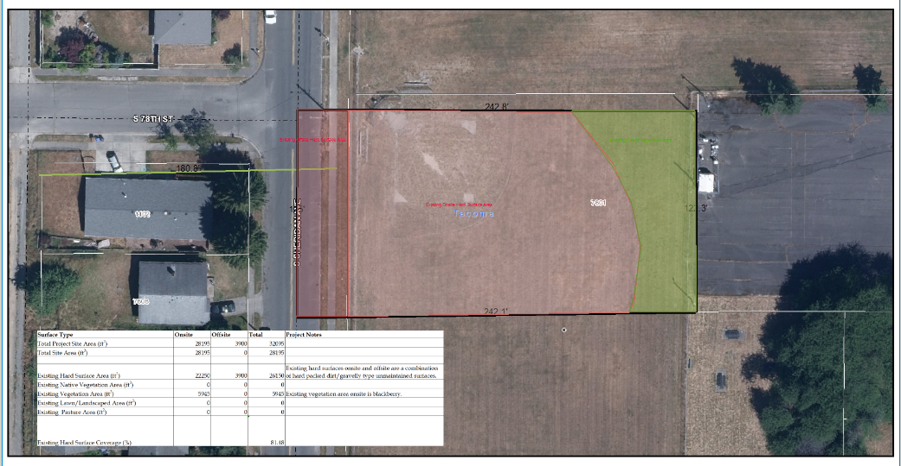

- Downstream Flowpath – Existing Condition
Figure 3 – Downstream Flowpath
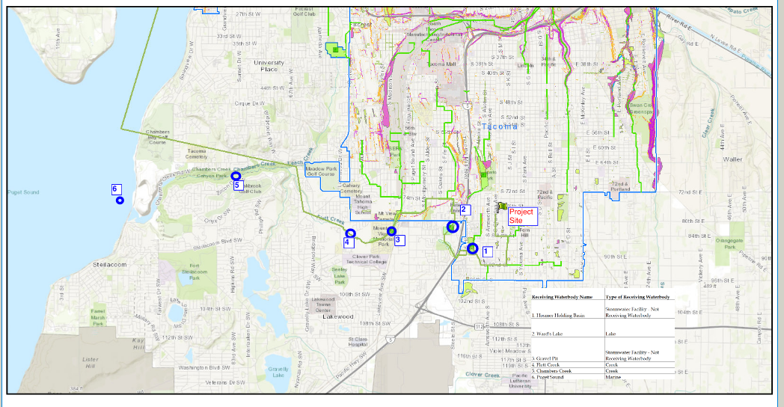

Proposed Project Site Conditions

A. Describe in words and provide figure(s) to describe the proposed project site conditions.

- Describe in one or two sentences the proposed project site use:
The proposed site is a convenience store with associated parking lot and drive aisles. Offsite improvements including sidewalk installation and roadway replacement are required. There will be no fuel tanks installed, no groundwater wells installed and no septic systems installed. No new easements are required for the project. See Civil Sheets C-07 and C-08 for the full site plan showing improvements.
- Describe in words or show on a figure the stormwater runoff patterns (natural and artificial) and the points where stormwater enters and exits the project site.
Stormwater runoff patterns remain the same between existing and proposed conditions. Stormwater generally enters the site from the west and will discharge into the City of Tacoma Stormwater System via a piped discharge to a structure.
- Provide a figure showing:
- the proposed improvements (buildings, sidewalks, parking lots, utilities, etc.),
- fuel tanks (above and below ground) that are proposed or will remain in place, proposed groundwater wells on the project site
- proposed septic systems
- proposed public and private easements
There will be no fuel tanks installed, no groundwater wells installed and no septic systems installed. No new easements are required for the project. See Civil Sheet C-07 and C-08 for full site plan showing improvements.
- Additional Information
No additional information needed.
See Civil Sheets C-07 and C-08

- Proposed Project Site Condition Basin Map .
Figure 4 – Example Proposed Project Site Condition Map (Note: this figure would not be approved because the legend for “Onsite Lawn/Landscaping Area” doesn’t match the hatch on the figure.)

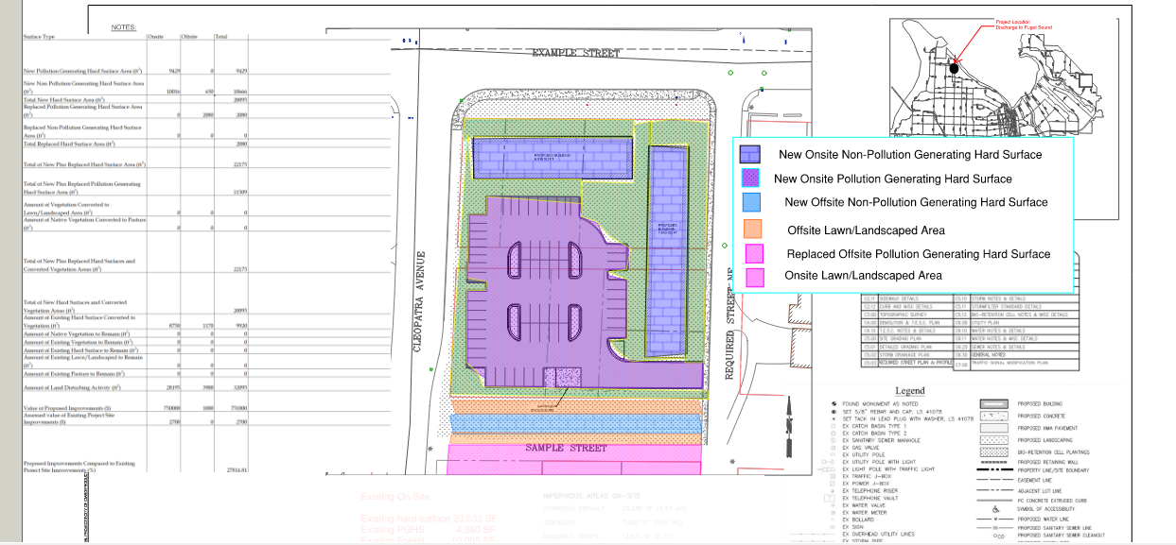
C. Downstream Flowpath – Proposed Condition
See Figure 3 – Downstream Flowpath. Flowpath does not change from existing to proposed conditions.

Minimum Requirement Determination

- Table 1 - Project Thresholds (note: this project has only one TDA)
Surface Type | Onsite | Offsite | Total
Total Project Site Area (ft²) | 28195 | 3900 | 32095
Total Site Area (ft²) | 28195 | 0 | 28195
Existing Hard Surface Area (ft²) | 22250 | 3900 | 26150
Existing Native Vegetation Area (ft²) | 0 | 0 | 0
Existing Vegetation Area (ft²) | 5945 | 0 | 5945
Existing Lawn/Landscaped Area (ft²) | 0 | 0 | 0
Existing Pasture Area (ft²) | 0 | 0 | 0
Existing Hard Surface Coverage (%) |  |  | 81.48
New Pollution Generating Hard Surface Area (ft²) | 9429 | 0 | 9429
New Non-Pollution Generating Hard Surface Area (ft²) | 10016 | 650 | 10666
Total New Hard Surface Area (ft²) |  |  | 20095
Replaced Pollution Generating Hard Surface Area (ft²) | 0 | 2080 | 2080
Replaced Non-Pollution Generating Hard Surface Area (ft²) | 0 | 0 | 0
Total Replaced Hard Surface Area (ft²) |  |  | 2080
Total of New Plus Replaced Hard Surface Area (ft²) |  |  | 22175
Total of New Plus Replaced Pollution Generating Hard Surface Area (ft²) |  |  | 11509
Amount of Vegetation Converted to Lawn/Landscaped Area (ft²) | 0 | 0 | 0
Amount of Native Vegetation Converted to Pasture (ft²) | 0 | 0 | 0
Total of New Plus Replaced Hard Surfaces and Converted Vegetation Areas (ft²) |  |  | 22175
Total of New Hard Surfaces and Converted Vegetation Areas (ft²) |  |  | 20095
Amount of Existing Hard Surface Converted to Vegetation (ft²) | 8750 | 1170 | 9920
Amount of Native Vegetation to Remain (ft²) | 0 | 0 | 0
Amount of Existing Vegetation to Remain (ft²) | 0 | 0 | 0
Amount of Existing Hard Surface to Remain (ft²) | 0 | 0 | 0
Amount of Existing Lawn/Landscaped to Remain (ft²) | 0 | 0 | 0
Amount of Existing Pasture to Remain (ft²) | 0 | 0 | 0
Amount of Land Disturbing Activity (ft²) | 28195 | 3900 | 32095
Value of Proposed Improvements ($) | 750000 | 1000 | 751000
Assessed value of Existing Project Site Improvements ($) | 2700 | 0 | 2700
Proposed Improvements Compared to Existing Project Site Improvements (%) |  |  | 27814.81

- Table 2- Receiving Waterbody Table
Receiving Waterbody Name | Type of Receiving Waterbody
Hosmer Holding Basin | Stormwater Facility - Not Receiving Waterbody
Ward's Lake | Lake
Gravel Pit | Stormwater Facility - Not Receiving Waterbody
Flett Creek | Creek
Chambers Creek | Creek
Puget Sound | Marine

- Table 3 – Minimum Requirements Required
Applicable Minimum Requirements | Applicable Surface Type Requiring Mitigation
MR #1-#5 | New and Replaced Hard Surfaces and Converted Vegetation Areas and Land Disturbed
MR#6 | New and Replaced PGHS
MR#7 | New and Replaced Hard Surfaces and Converted Vegetation Areas
MR#9 | NA

- Cumulative Impacts
  - Table (Insert Table Number)- Cumulative Impacts
NA
  - Cumulative Impacts Discussion
Development has not occurred on the site since 2003.

- Flowcharts
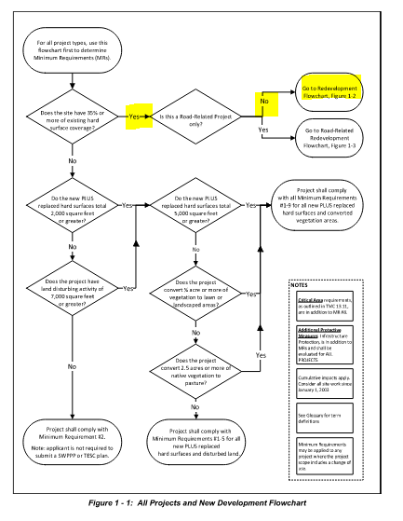
Figure 5 - All Projects and New Development Flowchart
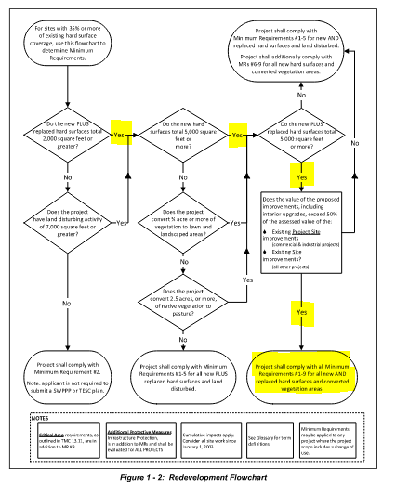
Figure 6 – Redevelopment Flowchart

Discussion of Minimum Requirements

Minimum Requirement #1 – Preparation of a Stormwater Site Plan
This Stormwater Site Plan Report and the Coldest Ice Convenience Store Civil Plans are being used to meet Minimum Requirement #1.
Description of Site Appropriate Development Principles
Where practicable, projects shall use the following site appropriate development principles. Put a checkmark next to the principles that will be used for the project. Project design is not required to be changed in order to accommodate site appropriate development principles, but where feasible, these principles must be used. If none of the site development principles are feasible, place a checkmark next to that box below.
☒ Minimization of land disturbance by fitting development to the natural terrain.
☒ Minimization of land disturbance by confining construction to the smallest area feasible and away from critical areas.
☐ Preservation of natural vegetation.
☐ Locating impervious surfaces over less permeable soils.
☐ Clustering buildings.
☐ Minimizing impervious surfaces.
☐ Site appropriate development principles are not practicable because of project design.

Minimum Requirement #2 – Construction Stormwater Pollution Prevention Plan
The Construction Stormwater Pollution Prevention Plan is available as a stand-alone document as part of the Permit submittal.

Minimum Requirement #3 – Source Control
- Description of Final Site Use
The final site will be a convenience store with associated parking lot and drive aisles. The convenience store will have a small deli section with precooked items.
- Source Control BMPs
Table 4 – Source Control BMPs
BMP | Property/Site Type or Activity Type | Potential Pollutant(s) Associated with Activity or Pollutant that BMP is being used for.
BMP S100: Correcting Illicit Discharges to the Stormwater System | All commercial and industrial sites. | Wastewater, process water.
BMP S101: Labeling Stormwater Inlet | All commercial and industrial sites. | Wastes from dumping.
BMP S102: Formation of a Pollution Prevention team | All commercial and industrial sites.
BMP S103: Preventative Maintenance/Good Housekeeping | All commercial and industrial sites.
BMP S104: Spill Prevention and Cleanup | All commercial and industrial sites. | Leaks and spills of liquid and solid waste.
BMP S105: Employee Training | All commercial and industrial sites.
BMP S106: Inspections | All commercial and industrial sites.
BMP S107: Record Keeping | All commercial and industrial sites.
BMP S111: Cleaning Building Structures and Related Equipment | Outside washing of building structures including pressure washing of sidewalks, walkways, etc. and/or where washing may come into contact with precipitation or stormwater. | Heavy metals, pH, suspended solids, grit, paint chips, and biochemical oxygen demand (BOD)
BMP S114: Loading and Unloading Areas for Liquid and Solid Material | Loading and unloading of liquid and solid materials at industrial and commercial sites. | Fuel leaks and spills, oils, powders, organics, heavy metals, salts, acids, alkalis
BMP S117: Storage of Solid Wastes and Food Wastes | Outside storage of solid waste including ordinary garbage and/or where storage may come into contact with precipitation or stormwater. | Toxic organic compounds, oil and grease, heavy metals, nutrients, suspended solids, COD, BOD
BMP S139: Stormwater System Maintenance | All properties with stormwater systems. | Excess sediment, oils, hydrocarbons and sediment
BMP S143: Landscaping and Lawn/Vegetation Management | Properties and areas in the ROW that have landscaping and/or lawn areas. | Toxic organic compounds, heavy metals, oils, total suspended solids, coliform bacteria, fertilizers, and pesticides.
BMP S162: Proper Disposal | Disposing of any liquid or solid waste. | Liquid and solid waste.

Minimum Requirement #4 – Preserving Drainage Patterns and Outfalls
- Description of Drainage Patterns and Outfalls
Stormwater will continue to flow in the general direction as the existing condition. Stormwater will discharge to the same receiving waterbodies as in the existing condition.
- Description of Concentrated and/or Increased Volume or Flowrate and Mitigation
This project is proposing to discharge stormwater to the City of Tacoma system. See Section 7 – Additional Protective Measure – Infrastructure Protection for more information.

Minimum Requirement #5 – Onsite Stormwater Management
This project will utilize: The List Approach
List #2 BMPs were analyzed for feasibility.
For Lawn and Landscaped Areas – BMP L613: Post Construction Soil Quality and Depth – Option 3 – Amend in Place will be used on all areas that will be lawn/landscaped in the final scenario.
For roofs the following BMPs were analyzed for feasibility.
BMP L602: Downspout Full Infiltration was deemed infeasible. See infeasibility checklist in Appendix A and Soils Report – Page 9. Per the Project Soils Report, high groundwater has made this BMP infeasible.
BMP L630: Bioretention was deemed infeasible. See infeasibility checklist in Appendix A and Soils Report – Page 9. Per the Project Soils Report, high groundwater has made this BMP infeasible.
BMP L603: Downspout dispersion was deemed infeasible. See infeasibility checklist in Appendix A and Figure 7 which shows flowpath distances cannot be maintained.
BMP L604: Perforated Stub-Outs was deemed infeasible. See infeasibility checklist in Appendix A and Soils Report – Page 9. . Per the Project Soils Report, high groundwater has made this BMP infeasible.
For Other Hard Surfaces the following were analyzed for infeasibility:
BMP L614: Full Dispersion was deemed infeasible. See infeasibility checklist – Appendix A.
BMP L633: Permeable Pavements was deemed infeasible. See infeasibility checklist – Appendix A and Soils Report – Page 9. . Per the Project Soils Report, high groundwater has made this BMP infeasible.
BMP L630: was deemed infeasible. See above.
BMP L612: Sheet Flow Dispersion was deemed infeasible. See infeasibility checklist and Figure 7 which shows flowpath length cannot be accommodated.

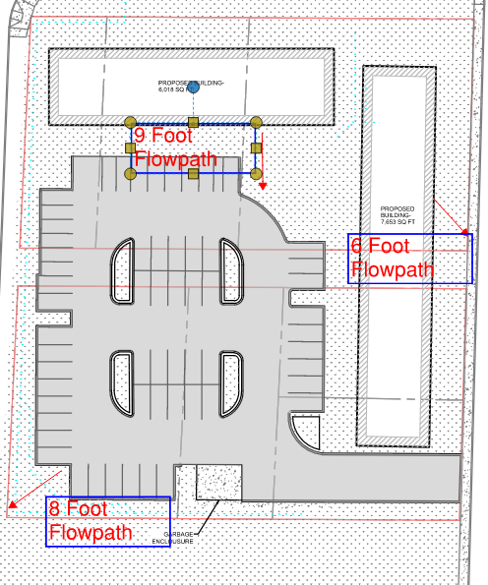
Figure 7 – Flowpath Lengths – Dispersion BMPs

Minimum Requirement #6 – Stormwater Treatment
- Description of Compliance Need
Minimum Requirement #6 is required for this project because the project creates more than 5,000 square feet of new and replaced pollution generating hard surface area. See Figure 8 – Stormwater Treatment Basin and Table 1 – Project Thresholds for quantities.
Project only has one TDA. Requirement applies to all new and replaced pollution generating hard surfaces.
- Compliance Mechanism(s)
- Treatment type required
Oil control is not required because there were less than 300 trip ends per day and ADT is less than 100 per 1000 SF of gross building area. See Traffic Report – Coldest Ice – Page 12. An excerpt from the Traffic Report is included below for reference.
“Per standard accepted engineering traffic study procedures, trips ends for this project have been determined to be 249 and ADT is 57 per 1000 SF of gross building area. See Traffic Report attached under separate cover.
Enhanced treatment is required for all pollution generating hard surfaces.
- Stormwater treatment basin map
See Figure 8 – Stormwater Treatment Basin Map
- State the BMP(s) being used.
Onsite a bioretention facility (BMP T630) with an underdrain and liner will be used to treat stormwater. Offsite, a filterra unit (BMP T1300) will be used to treat the pollution-generating surfaces in the Right-of-Way. See Appendix B for complete calculations.
The filterra GULD is included in Appendix E.
Note: In MR #5 discussion, it is stated that BMP T630 is not feasible due to high groundwater, that was referring to a bioretention facility that would infiltrate. This bioretention facility will be used for treatment only and will not infiltrate due to the liner and underdrain.

Figure 8 – Stormwater Treatment Basin Map
NOTE: for this SSP to be approved, changes to the hatches would be required for clarity.
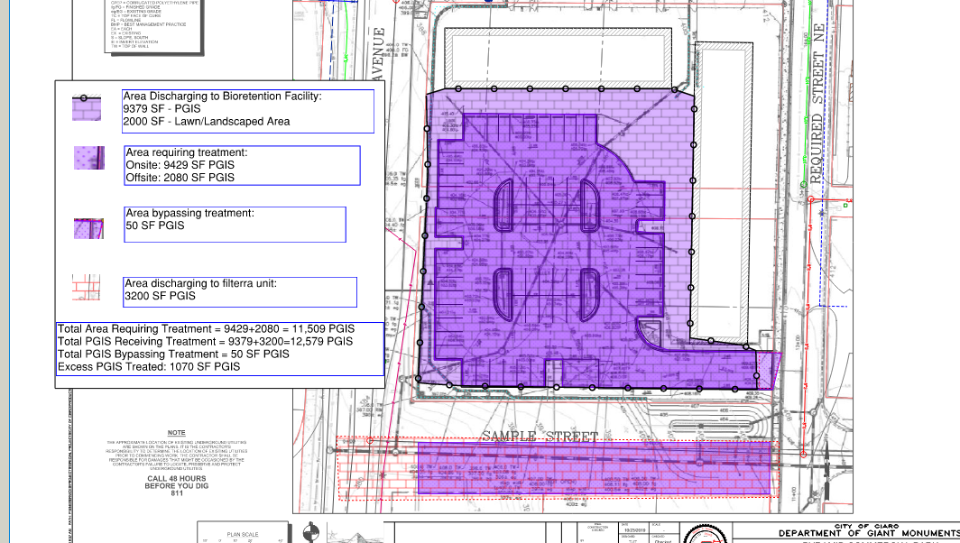

Minimum Requirement #7 – Flow Control
- Description of Compliance Need
This project creates more than 10,000 square feet of effective impervious surface so flow control is required. See Figure 9 – Flow Control Basin Map and Table 1 – Project Thresholds for quantities.
Project only has one TDA. Requirement applies to all new and replaced hard surfaces.
- Compliance Mechanism(s)
- Describe flow control type required (ex. Forested, existing).
Project is required to provide flow control to forested conditions. Project is proposing to participate in the City of Tacoma Fee In-Lieu Program. See stand-alone Fee In-Lieu application.
- Provide a flow basin map clearly showing surfaces requiring flow control and surfaces receiving flow control (facility contributing areas).
See Figure 9 – Flow Control Basin Map
- State the BMP(s) being used.
The project will utilize the City of Tacoma Fee In-Lieu Program. The application form is included as a separate document.

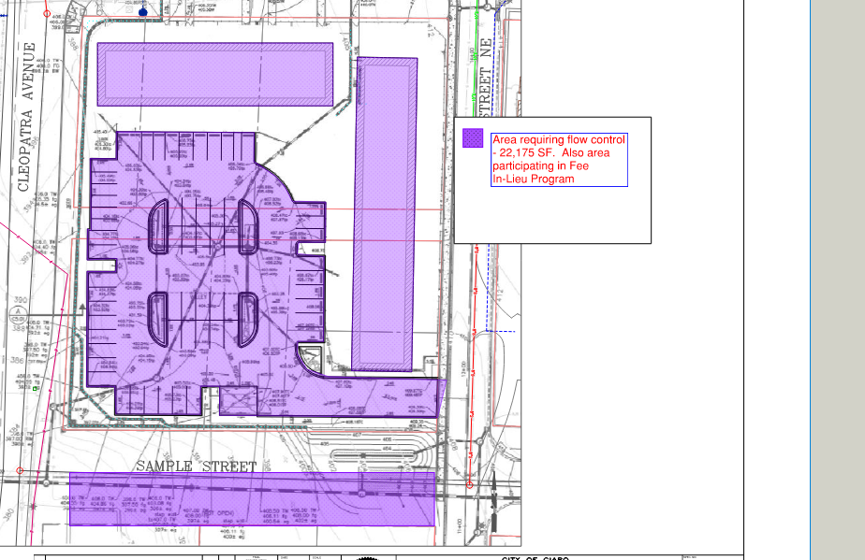
Figure 9 – Flow Control Basin Map

Minimum Requirement #8 – Wetlands Protection
- Description of Compliance Need
The project is not required to comply with MR #8 because the project does not discharge into a wetland.

Minimum Requirement #9 – Operation and Maintenance

For facilities that will be maintained by a private property owner include the following language: The Operation and Maintenance Manual is available as a stand-alone document as part of the Permit submittal.
For facilities that will be maintained by the City of Tacoma include the following language: The City of Tacoma is responsible for creating and keeping an Operation and Maintenance Manual for all facilities that will be maintained by the City of Tacoma.

Additional Protective Measure – Infrastructure Protection

- Description of Compliance Need
The project is not required to complete a quantitative downstream analysis. The project does not add any surface area to the downstream system (everything in the current condition enters the City stormwater system). The changes from pervious to impervious surface are less than 5,000 square feet – there is a decrease in impervious surface area. Per the SWMM volume 1 Section 1.5, no analysis is required.

Conveyance System Design

- Include all information necessary to show how the conveyance system was designed.
See Appendix B for all calculation outputs. The onsite conveyance system was designed assuming backwater effects to have 0.5 feet of freeboard between the water surface and the top of the maintenance hole or catch basin at the 10-year, 24-hour storm event. At the 100-year, 24-hour storm event, no overtopping was shown in the modeling outputs.

Appendices

Minimum Requirement #5 – Infeasibility Checklists

City of Tacoma Stormwater Management Manual – Infeasibility Checklist

Surface Type: Roofs
BMP L602: Downspout Full Infiltration (Infiltration Trenches and Drywells)

Version: 07/01/2021
It is not necessary to answer all questions when determining if a BMP is feasible for Minimum Requirement #5 – The List Approach. Unless otherwise noted, a single answer of No means the BMP is considered infeasible for meeting Minimum Requirement #5 – The List Approach. Applicant may choose which questions to answer when determining feasibility.
Questions #1-7 relate to infeasibility criteria that are based on conditions such as topography and distances to predetermined boundaries and certain design criteria.
Question Number | Question | Yes | No | NA
1 | Can the infiltration trench or drywell be placed 10 feet or more from any building structure? | ☐ | ☐ | ☐
2 | Can the infiltration trench or drywell be placed 5 feet or more from any other structure or property line? | ☐ | ☐ | ☐
3 | Can the infiltration trench or drywell be placed 50 feet or more from the top of any slope 20% or greater? | ☐ | ☐ | ☐
4 | Can the infiltration trench or drywell be placed 50 feet or more from geologically hazardous areas? | ☐ | ☐ | ☐
5 | Can the infiltration trench or drywell meet setback requirements from Onsite Sewage Systems per WAC 246-272A-0210? | ☐ | ☐ | ☐
6 | Will installing an infiltration trench or drywell cause conflicts with any of the following? (An answer of yes means this BMP is infeasible.) Place a checkmark next to the applicable item (6a-6e). | ☐ | ☐ | ☐
6a | Requirements of the Historic Preservation Laws and Archeology Laws, Federal Superfund or Washington State Model Toxics Control Act, Federal Aviation Administration requirements for airports, or Americans with Disability Act | ☐
6b | Special zoning district design criteria adopted and being implemented through any City of Tacoma planning efforts | ☐
6c | Public health and safety standards | ☐
6d | Transportation regulations to maintain the option for future expansion or multi-modal use of public rights-of-way | ☐
6e | Critical Area Preservation Ordinance | ☐
7 | Can the design standards in BMP L602 be met? | ☐ | ☐ | ☐
7a | Describe the design standards that cannot be met:
Questions #8-10 relate to infeasibility criteria that are based upon subsurface characteristics and require a soils report to determine infeasibility.
8 | Was the soil classified as being clay, sandy clay, clay loam, silty clay loam, sandy clay loam, or silt according to the USDA Textural Soil Triangle? (An answer of yes means this BMP is not feasible). | ☐ | ☐ | ☐
9 | Is the depth from proposed final grade to the seasonal high groundwater table or other impermeable layer equal to or greater than 3 feet? | ☐ | ☒ | ☐
10 | Is the depth from the bottom of the infiltration trench or drywell to the seasonal high groundwater table equal to or greater than 1 foot? | ☐ | ☐ | ☐

City of Tacoma Stormwater Management Manual – Infeasibility Checklist

Surface Type: Roofs or Other Hard Surface

BMP L630: Bioretention

Version: 07/01/2021
It is not necessary to answer all questions when determining if a BMP is feasible for Minimum Requirement #5 – The List Approach. Unless otherwise noted, a single answer of No means the BMP is considered infeasible for meeting Minimum Requirement #5 – The List Approach. Applicant may choose which questions to answer when determining feasibility.
Questions #1-18 relate to infeasibility criteria that are based on conditions such as topography and distances to predetermined boundaries. Citation of the following do not need site-specific written recommendations from a Washington State Licensed Professional Engineer or Washington State Licensed Professional Geologist though some criteria may require professional services to determine if the infeasibility criteria apply.
Question Number | Question | Yes | No | NA
1 | Can the bioretention facility be placed 10 feet or more from any building structure? | ☐ | ☐ | ☐
2 | Can the bioretention facility be placed 5 feet or more from any other structure or property line? | ☐ | ☐ | ☐
3 | Can the bioretention facility be placed 50 feet or more from the top of any slope greater than 20%? | ☐ | ☐ | ☐
4 | Can the bioretention facility be placed 50 feet or more from geologically hazardous areas? | ☐ | ☐ | ☐
5 | Can the bioretention facility be located outside of designated erosion or landslide hazard areas? | ☐ | ☐ | ☐
6 | Can the bioretention facility be located greater than 100 feet from an underground storage tank whose capacity including tank and underground connecting pipe is 1100 gallons or more? | ☐ | ☐ | ☐
7 | Can the bioretention facility be located greater than 10 feet from an underground storage tank (tank used for petroleum product, chemical, or liquid hazardous waste storage) whose capacity including tank and underground connecting pipe is 1100 gallons or less? | ☐ | ☐ | ☐
8 | Can the bioretention facility be located greater than 100 feet of a closed or active landfill? | ☐ | ☐ | ☐
9 | Can the bioretention facility be located greater than 100 feet from drinking water well or a spring used for drinking water supply? | ☐ | ☐ | ☐
10 | Can the bioretention facility be placed 10 feet or more from small on-site sewage disposal drainfields? (For large on-site sewage disposal setbacks see WAC Chapter 246-727B). | ☐ | ☐ | ☐
11 | Can the bioretention facility be located on slopes less than 8%? | ☐ | ☐ | ☐
12 | Is the bioretention facility compatible with the surrounding drainage system (e.g., project drains to an existing stormwater system whose elevation precludes proper connection to the bioretention facility)? | ☐ | ☐ | ☐
13 | For properties with known soil or groundwater contamination, can the bioretention facility be located greater than 100 feet from an area known to have deep soil contamination? | ☐ | ☐ | ☐
14 | For properties with known soil or groundwater contamination, can the bioretention facility be located such that infiltration will not increase or change the direction of the migration of pollutants in the groundwater? (Based upon groundwater modeling). | ☐ | ☐ | ☐
15 | For properties with known soil or groundwater contamination, can the bioretention facility be located in an area that does not have contaminated surface soils that are proposed to remain in place? | ☐ | ☐ | ☐
16 | For properties with known soil or groundwater contamination, can the bioretention facility be located in areas not prohibited by an approved cleanup plan under the state Model Toxics Control Act or Federal Superfund Law, or an environmental covenant under Chapter 64.70 RCW? | ☐ | ☐ | ☐
17 | For bioretention facilities that are constructed with imported compost materials, can the bioretention facility be located greater than ¼ mile from a phosphorus-sensitive waterbody? (Does not apply to discharges to Wapato Lake). | ☐ | ☐ | ☐
18 | Will installing a bioretention facility cause conflicts with any of the following? (An answer of yes means this BMP is infeasible.) Place a checkmark next to the applicable item (18a-18e). | ☐ | ☐ | ☐
18a | Requirements of the Historic Preservation Laws and Archeology Laws, Federal Superfund or Washington State Model Toxics Control Act, Federal Aviation Administration requirements for airports, or Americans with Disability Act | ☐
18b | Special zoning district design criteria adopted and being implemented through any City of Tacoma planning efforts | ☐
18c | Public health and safety standards | ☐
18d | Transportation regulations to maintain the option for future expansion or multi-modal use of public rights-of-way | ☐
18e | Critical Area Preservation Ordinance | ☐
Questions #19-21 relate to infeasibility criteria that are based upon subsurface characteristics and require a soils report to determine infeasibility.
19 | Is the depth from the lowest level of the bioretention soil mix or any underlying gravel layer to the seasonal high groundwater table or other impermeable layer equal to or greater than 1 foot? This applies only if the contributing area to the bioretention facility has less than 5,000 square feet of pollution-generating impervious surface, and less than 10,000 square feet of impervious surface, and less than ¾ acre pervious surface. | ☐ | ☐ | ☐
20 | Is the depth from the lowest level of the bioretention soil mix or any underlying gravel layer to the seasonal high groundwater table or other impermeable layer equal to or greater than 3 feet? This applies only if the contributing area to the bioretention facility has: 5,000 square feet or greater of pollution-generating impervious surface, or 10,000 square feet or greater of impervious surface, or more ¾ acre pervious surface AND the bioretention facility cannot be broken down into amounts smaller than those listed above. | ☐ | ☒ | ☐
21 | Was the soil classified as having a measured native soil saturated hydraulic conductivity of 0.3 in/hour or more? | ☐ | ☐ | ☐
Questions 22-29 require evaluation of site specific conditions and a written recommendation from an appropriate Washington State Licensed Professional (e.g., Professional Engineer, Professional Geologist, Professional Hydrogeologist).
22 | Will the proposed bioretention facility location threaten the safety or reliability of preexisting underground utilities, preexisting underground storage tanks, preexisting structures, or preexisting road or parking lot surfaces? (An answer of yes means the BMP is infeasible). | ☐ | ☐ | ☐
23 | Will the proposed bioretention facility location allow for a safe overflow pathway to the City stormwater system or a private stormwater system? | ☐ | ☐ | ☐
24 | Are there reasonable concerns about erosion, slope failure, or downgradient flooding due to infiltration? (An answer of yes means the BMP is infeasible). | ☐ | ☐ | ☐
25 | Is the project located in an area whose groundwater drains into an erosion hazard or landslide hazard area? (An answer of yes means the BMP is infeasible). | ☐ | ☐ | ☐
26 | Will infiltrating water threaten existing below grade basements? (An answer of yes means the BMP is infeasible). | ☐ | ☐ | ☐
27 | Will infiltrating water threaten shoreline structures such as bulkheads? (An answer of yes means the BMP is infeasible). | ☐ | ☐ | ☐
28 | Is there lack of usable space onsite for bioretention facilities at redevelopment sites? (An answer of yes means the BMP is infeasible). | ☐ | ☐ | ☐
29 | For public road projects, is there insufficient space within the ROW to install a bioretention facility? (An answer of yes means this BMP is infeasible). | ☐ | ☐ | ☐

City of Tacoma Stormwater Management Manual – Infeasibility Checklist

Surface Type: Roofs and Other Hard Surfaces
BMP L614: Full Dispersion

Version: 07/01/2021
It is not necessary to answer all questions when determining if a BMP is feasible for Minimum Requirement #5 – The List Approach. Unless otherwise noted, a single answer of No means the BMP is considered infeasible for meeting Minimum Requirement #5 – The List Approach. Applicant may choose which questions to answer when determining feasibility.
Questions #1-9 relate to infeasibility criteria that are based on conditions such as topography and distances to predetermined boundaries and certain design criteria.
Question Number |  | Question | Yes |  |  | No | NA
1 |  | Can the flow spreader and dispersion areas be placed 10 feet or more from any building structure? | ☐ |  |  | ☐ | ☐
2 |  | Can the flow spreader and dispersion areas be placed 5 feet or more from any other structure or property line? | ☐ |  |  | ☐ | ☐
3 |  | Can the dispersion areas be placed 50 feet or more from the top of any slope 15% or greater? | ☐ |  |  | ☐ | ☐
4 |  | Can the dispersion areas be placed 50 feet or more from geologically hazardous areas? | ☐ |  |  | ☐ | ☐
5 |  | Can the dispersion area be located outside of critical areas, critical area buffers, streams, or lakes? | ☐ |  |  | ☐ | ☐
6 |  | Can the flow spreader and dispersion area maintain setbacks from Onsite Sewage Systems per WAC 246-272A-0210? | ☐ |  |  | ☐ | ☐
8 |  | Will installing a full dispersion system cause conflicts with any of the following? (An answer of yes means this BMP is infeasible.) Place a checkmark next to the applicable item (8a-8e). | ☐ |  |  | ☐ | ☐
8a |  | Requirements of the Historic Preservation Laws and Archeology Laws, Federal Superfund or Washington State Model Toxics Control Act, Federal Aviation Administration requirements for airports, or Americans with Disability Act | ☐
8b |  | Special zoning district design criteria adopted and being implemented through any City of Tacoma planning efforts | ☐
8c |  | Public health and safety standards | ☐
8d |  | Transportation regulations to maintain the option for future expansion or multi-modal use of public rights-of-way | ☐
8e |  | Critical Area Preservation Ordinance | ☐
9 |  | Can the design standards in BMP L614 be met? | ☐ |  |  | ☒ | ☐
9a |  | Describe the design standard that cannot be met: Full Dispersion is not intended for commercial properties.
Questions #10 require evaluation of site specific conditions and a written recommendation from an appropriate Washington State Licensed Professional (e.g., Professional Engineer, Professional Geologist, Professional Hydrogeologist).
10 |  | Will the use of a full dispersion cause erosion or flooding problems onsite or on adjacent properties? (An answer of yes means this BMP is not feasible). | ☐ |  |  | ☐ | ☐

City of Tacoma Stormwater Management Manual – Infeasibility Checklist

Surface Type: Roofs
BMP L603: Downspout Dispersion (Dispersion Trenches and Splashblocks)

Version: 07/01/2021
It is not necessary to answer all questions when determining if a BMP is feasible for Minimum Requirement #5 – The List Approach. Unless otherwise noted, a single answer of No means the BMP is considered infeasible for meeting Minimum Requirement #5 – The List Approach. Applicant may choose which questions to answer when determining feasibility.
Questions #1-10 relate to infeasibility criteria that are based on conditions such as topography and distances to predetermined boundaries and certain design criteria.
Question Number |  | Question | Yes |  |  | No | NA
1 |  | Can the dispersion trench or splashblocks be placed 10 feet or more from any building structure? | ☐ |  |  | ☐ | ☐
2 |  | Can the dispersion trench or splashblocks be placed 5 feet or more from any other structure or property line? | ☐ |  |  | ☐ | ☐
3 |  | Can the dispersion trench or splashblocks be placed 50 feet or more from the top of any slope 15% or greater? | ☐ |  |  | ☐ | ☐
4 |  | Can the dispersion trench or splashblocks be placed 50 feet or more from geologically hazardous areas? | ☐ |  |  | ☐ | ☐
5 |  | Can the dispersion trench or splashblock maintain setbacks from Onsite Sewage Systems per WAC 246-272A-0210? | ☐ |  |  | ☐ | ☐
6 |  | Is it possible to maintain or construct a vegetated flowpath of at least 25 feet from the outlet of a dispersion trench and any property line, structure, stream, wetland, other infiltration or dispersion system, or impervious surface? | ☐ |  |  | ☒ | ☐
7 |  | Is it possible to maintain or construct a vegetated flowpath of at least 50 feet from the outlet of a dispersion trench and any slope greater than 15%? | ☐ |  |  | ☐ | ☐
8 |  | Is it possible to maintain or construct a vegetated flowpath of at least 50 feet from the outlet of splashblock and any property line, structure, slope over 15%, stream, wetland, other infiltration or dispersion system, or impervious surface? | ☐ |  |  | ☐ | ☐
9 |  | Will installing a dispersion trench or splashblocks cause conflicts with any of the following? (An answer of yes means this BMP is infeasible.) Place a checkmark next to the applicable item (9a-9e). | ☐ |  |  | ☐ | ☐
9a |  | Requirements of the Historic Preservation Laws and Archeology Laws, Federal Superfund or Washington State Model Toxics Control Act, Federal Aviation Administration requirements for airports, or Americans with Disability Act | ☐
9b |  | Special zoning district design criteria adopted and being implemented through any City of Tacoma planning efforts | ☐
9c |  | Public health and safety standards | ☐
9d |  | Transportation regulations to maintain the option for future expansion or multi-modal use of public rights-of-way | ☐
9e |  | Critical Area Preservation Ordinance | ☐
10 |  | Can the design standards in BMP L603 be met? | ☐ |  |  | ☐ | ☐
10a |  | Describe the design standard that cannot be met:
Questions #11 require evaluation of site specific conditions and a written recommendation from an appropriate Washington State Licensed Professional (e.g., Professional Engineer, Professional Geologist, Professional Hydrogeologist).
11 |  | Will the use of a dispersion trench or splashblocks cause erosion or flooding problems onsite or on adjacent properties? (An answer of yes means this BMP is not feasible). | ☐ |  |  | ☐ | ☐

City of Tacoma Stormwater Management Manual – Infeasibility Checklist

Surface Type: Roofs
BMP L604: Perforated Stub-out Connections.

Version: 07/01/2021
It is not necessary to answer all questions when determining if a BMP is feasible for Minimum Requirement #5 – The List Approach. Unless otherwise noted, a single answer of No means the BMP is considered infeasible for meeting Minimum Requirement #5 – The List Approach. Applicant may choose which questions to answer when determining feasibility.
Questions #1-7 relate to infeasibility criteria that are based on conditions such as topography and distances to predetermined boundaries and certain design criteria.
Question Number |  | Question | Yes |  |  | No | NA
1 |  | Can the perforated stub-out connection be placed 10 feet or more from any building structure? | ☐ |  |  | ☐ | ☐
2 |  | Can the perforated stub-out connection be placed 5 feet or more from any other structure or property line? | ☐ |  |  | ☐ | ☐
3 |  | Can the perforated stub-out connection be placed 50 feet or more from the top of any slope 20% or greater? | ☐ |  |  | ☐ | ☐
4 |  | Can the perforated stub-out connection be placed 50 feet or more from geologically hazardous areas? | ☐ |  |  | ☐ | ☐
5 |  | Can the perforated stub-out connection meet setback requirements from Onsite Sewage Systems per WAC 246-272A-0210? | ☐ |  |  | ☐ | ☐
6 |  | Will installing a perforated stub-out connection cause conflicts with any of the following? (An answer of yes means this BMP is infeasible.) Place a checkmark next to the applicable item (6a-6e). | ☐ |  |  | ☐ | ☐
6a |  | Requirements of the Historic Preservation Laws and Archeology Laws, Federal Superfund or Washington State Model Toxics Control Act, Federal Aviation Administration requirements for airports, or Americans with Disability Act | ☐
6b |  | Special zoning district design criteria adopted and being implemented through any City of Tacoma planning efforts | ☐
6c |  | Public health and safety standards | ☐
6d |  | Transportation regulations to maintain the option for future expansion or multi-modal use of public rights-of-way | ☐
6e |  | Critical Area Preservation Ordinance | ☐
7 |  | Can the design standards in BMP L604 be met? | ☐ |  |  | ☐ | ☐
7a |  | Describe the design standard that cannot be met:
Questions #8 relates to infeasibility criteria that are based upon subsurface characteristics and require a soils report to determine infeasibility.
8 |  | Is the depth from the bottom of the perforated stub-out connection to the seasonal high groundwater table equal to or greater than 1 foot? | ☐ |  |  | ☒ | ☐

City of Tacoma Stormwater Management Manual – Infeasibility Checklist

Surface Type: Other Hard Surface

BMP L633: Permeable Pavement

Version: 07/01/2021
It is not necessary to answer all questions when determining if a BMP is feasible for Minimum Requirement #5 – The List Approach. Unless otherwise noted, a single answer of No means the BMP is considered infeasible for meeting Minimum Requirement #5 – The List Approach. Applicant may choose which questions to answer when determining feasibility.
Questions #1-24 relate to infeasibility criteria that are based on conditions such as topography and distances to predetermined boundaries. Citation of the following do not need site-specific written recommendations from a Washington State Licensed Professional Engineer or Washington State Licensed Professional Geologist though some criteria may require professional services to determine if the infeasibility criteria apply.
Question Number | Question |  |  | Yes | No |  | NA
1 | Can the permeable pavement be placed 10 feet or more from any building structure? |  |  | ☐ | ☐ |  | ☐
2 | Can the permeable pavement be placed 5 feet or more from any other structure or property line? |  |  | ☐ | ☐ |  | ☐
3 | Can the permeable pavement be placed 50 feet or more from the top of any slope greater than 20%? |  |  | ☐ | ☐ |  | ☐
4 | Can the permeable pavement be placed 50 feet or more from geologically hazardous areas? |  |  | ☐ | ☐ |  | ☐
5 | Can the permeable pavement be located outside of designated erosion or landslide hazard areas? |  |  | ☐ | ☐ |  | ☐
7 | Can the permeable pavement be located greater than 10 feet from an underground storage tank (tank used for petroleum product, chemical, or liquid hazardous waste storage) whose capacity including tank and underground connecting pipe is 1100 gallons or less? |  |  | ☐ | ☐ |  | ☐
8 | Can the permeable pavement be located greater than 100 feet of a closed or active landfill? |  |  | ☐ | ☐ |  | ☐
9 | Can the permeable pavement be located greater than 100 feet from drinking water well or a spring used for drinking water supply if the permeable pavement is (or has run-on from) a pollution-generating hard surface? |  |  | ☐ | ☐ |  | ☐
10 | Can the permeable pavement be placed 10 feet or more from small on-site sewage disposal drainfields? (For large on-site sewage disposal setbacks see WAC Chapter 246-727B). |  |  | ☐ | ☐ |  | ☐
11 | Can the permeable pavement be constructed such that the subgrade is less than 6%? |  |  | ☐ | ☐ |  | ☐
12 | Can the permeable pavement be constructed such that the wearing course is less than 6% (after reasonable attempts have been made to design the grade)? |  |  | ☐ | ☐ |  | ☐
13 | Is the location for permeable pavement a multi-level parking garage, above a culvert, or a bridge? An answer of yes means the BMP is not feasible. |  |  | ☐ | ☐ |  | ☐
14 | Does the road receive more than very low traffic volumes? (Roads with a projected average daily traffic volume of 400 vehicles or less). This infeasibility criterion cannot be used for sidewalks or non-traffic bearing surfaces. An answer of yes means the BMP is not feasible. |  |  | ☐ | ☐ |  | ☐
15 | Does the road receive more than very low truck traffic? (Roads not subject to through truck traffic but may receive up to weekly use by utility trucks, daily school bus use, and multiple daily use by pick-up trucks, mail/parcel delivery trucks, and maintenance vehicles.). This infeasibility criterion cannot be used for sidewalks or non-traffic bearing surfaces. An answer of yes means the BMP is not feasible. |  |  | ☐ | ☐ |  | ☐
16 | Does the area typically generate high concentrations of oil due to high traffic turnover or frequent transfer of oil? (See SWMM for additional guidance.) An answer of yes means the BMP is not feasible. |  |  | ☐ | ☐ |  | ☐
17 | Can the permeable pavement be located outside of areas with industrial activity as identified in 40 CFR 122.26(b)14? |  |  | ☐ | ☐ |  | ☐
18 | Can permeable pavement be located outside of areas where the risk of concentrated pollutant spills is likely such as gas stations, truck stops, and industrial chemical storage areas? |  |  | ☐ | ☐ |  | ☐
19 | Can permeable pavement be located outside of areas likely to have long-term excessive sediment deposition after construction? |  |  | ☐ | ☐ |  | ☐
20 | For properties with known soil or groundwater contamination, can the permeable pavement be located greater than 100 feet from an area known to have deep soil contamination? |  |  | ☐ | ☐ |  | ☐
21 | For properties with known soil or groundwater contamination, can the permeable pavement be located such that infiltration will not increase or change the direction of the migration of pollutants in the groundwater? (Based upon groundwater modeling). |  |  | ☐ | ☐ |  | ☐
22 | For properties with known soil or groundwater contamination, can the permeable pavement be located in an area that does not have contaminated surface soils that are proposed to remain in place? |  |  | ☐ | ☐ |  | ☐
23 | For properties with known soil or groundwater contamination, can the permeable pavement be located in areas not prohibited by an approved cleanup plan under the state Model Toxics Control Act or Federal Superfund Law, or an environmental covenant under Chapter 64.70 RCW? |  |  | ☐ | ☐ |  | ☐
24 | Will installing permeable pavement cause conflicts with any of the following? (An answer of yes means this BMP is infeasible.) Place a checkmark next to the applicable item (24a-24e). |  |  | ☐ | ☐ |  | ☐
24a | Requirements of the Historic Preservation Laws and Archeology Laws, Federal Superfund or Washington State Model Toxics Control Act, Federal Aviation Administration requirements for airports, or Americans with Disability Act |  |  | ☐
24b | Special zoning district design criteria adopted and being implemented through any City of Tacoma planning efforts |  |  | ☐
24c | Public health and safety standards |  |  | ☐
24d | Transportation regulations to maintain the option for future expansion or multi-modal use of public rights-of-way |  |  | ☐
24e | Critical Area Preservation Ordinance |  |  | ☐
Questions #25-28 relate to infeasibility criteria that are based upon subsurface characteristics and require a soils report to determine infeasibility.
25 | Is the depth from the lowest layer designed as part of the permeable pavement section to the seasonal high groundwater elevation, bedrock, or other impermeable layer equal to or greater than 1 foot? |  |  | ☐ | ☒ |  | ☐
26 | For pollution generating pervious pavement surfaces, can the soil suitability criteria for treatment be met? (See SWMM – BMP L633) |  |  | ☐ | ☐ |  | ☐
27 | Was the soil classified as having a measured native soil saturated hydraulic conductivity of 0.3 in/hour or more? |  |  | ☐ | ☐ |  | ☐
28 | Is the existing impervious surface that will be replaced non-polluting generating and located over an outwash soil with a saturated hydraulic conductivity of 4 inches/hour or greater? |  |  | ☐ | ☐ |  | ☐
Questions 29-40 require evaluation of site specific conditions and a written recommendation from an appropriate Washington State Licensed Professional (e.g., Professional Engineer, Professional Geologist, Professional Hydrogeologist).
29 | Will the proposed permeable pavement location threaten the safety or reliability of preexisting underground utilities, preexisting underground storage tanks, preexisting structures, or preexisting road or parking lot surfaces? (An answer of yes means the BMP is infeasible). |  |  | ☐ | ☐ |  | ☐
30 | Will infiltrating and ponded water compromise existing adjacent impervious pavements? (An answer of yes means the BMP is infeasible). |  |  | ☐ | ☐ |  | ☐
31 | Are there reasonable concerns about erosion, slope failure, or downgradient flooding due to infiltration? (An answer of yes means the BMP is infeasible). |  |  | ☐ | ☐ |  | ☐
32 | Can the permeable pavement be located outside area whose groundwater drains into an erosion hazard or landslide hazard area? |  |  | ☐ | ☐ |  | ☐
33 | Will infiltrating water threaten existing below grade basements? (An answer of yes means the BMP is infeasible). |  |  | ☐ | ☐ |  | ☐
34 | Will infiltrating water threaten shoreline structures such as bulkheads? (An answer of yes means the BMP is infeasible). |  |  | ☐ | ☐ |  | ☐
35 | Can permeable pavement be located away from the bottom of steep, erosion prone areas that are likely to erode sediment? |  |  | ☐ | ☐ |  | ☐
36 | Can permeable pavement be located away from fill soils that can become unstable when saturated? |  |  | ☐ | ☐ |  | ☐
37 | Will permeable pavement construction on steep slopes cause erosion and structural failure? (An answer of yes means the BMP is infeasible). |  |  | ☐ | ☐ |  | ☐
38 | Will permeable pavement construction on steep slopes cause runoff velocities that preclude adequate infiltration at the pavement surfaces? (An answer of yes means the BMP is infeasible). |  |  | ☐ | ☐ |  | ☐
39 | Can permeable pavement provide sufficient strength to support the anticipated loads? |  |  | ☐ | ☐ |  | ☐
40 | Are underlying soils suitable for supporting traffic loads when saturated? |  |  | ☐ | ☐ |  | ☐

Soils Report

The Soils Report is available as a stand-alone document as part of the Permit submittal. It is titled: Coldest Ice Convenience Store – Geotechnical Analysis – Dated 04/17/2021.

Stormwater Treatment Calculations

Filterra Calculations:
Offline Water Quality Flowrate: 0.0062 CFS
Snip from WWHM Calculation – See Full WWHM Report After This Calculation
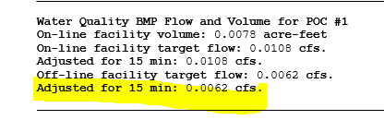
Per General Use Level Designation, the minimum size filter surface-area is calculated by dividing the water quality flowrate (ft³/sec) by the infiltration rate (ft/sec) to obtain required surface area (ft²)
Infiltration Rate (per GULD) for Enhanced Treatment: 175 in/hour.
175 in/hr * (1 hr/3600 sec) * (1ft/12in) = 0.0041ft/sec
0.0062 ft³/sec / 0.0041 ft/sec = 1.512 ft²
A 4 x 4 filterra Vault will be used.

WWHM2012
PROJECT REPORT
___________________________________________________________________

Project Name: Offsite Stormwater Treatment – filterra Unit
Site Name:
Site Address:
City :
Report Date: 5/18/2021
Gage :
Data Start : 10/01/1901
Data End : 09/30/2059
Precip Scale: 1.00
Version Date: 2019/09/13
Version : 4.2.17
___________________________________________________________________

Low Flow Threshold for POC 1 : 50 Percent of the 2 Year
___________________________________________________________________

High Flow Threshold for POC 1: 50 year
___________________________________________________________________

PREDEVELOPED LAND USE

Name : Basin 1
Bypass: No

GroundWater: No

Pervious Land Use acre

Pervious Total 0

Impervious Land Use acre
ROADS FLAT 0.073

Impervious Total 0.073

Basin Total 0.073

___________________________________________________________________

Element Flows To:
Surface Interflow Groundwater

___________________________________________________________________

MITIGATED LAND USE

Name : Basin 1
Bypass: No

GroundWater: No

Pervious Land Use acre

Pervious Total 0

Impervious Land Use acre
ROADS FLAT 0.073

Impervious Total 0.073

Basin Total 0.073

___________________________________________________________________

Element Flows To:
Surface Interflow Groundwater

___________________________________________________________________

___________________________________________________________________

ANALYSIS RESULTS

Stream Protection Duration

___________________________________________________________________

Predeveloped Landuse Totals for POC #1
Total Pervious Area:0
Total Impervious Area:0.073
___________________________________________________________________

Mitigated Landuse Totals for POC #1
Total Pervious Area:0
Total Impervious Area:0.073
___________________________________________________________________

Flow Frequency Return Periods for Predeveloped. POC #1
Return Period Flow(cfs)
2 year 0.025583
5 year 0.034341
10 year 0.040706
25 year 0.049417
50 year 0.056409
100 year 0.063845

Flow Frequency Return Periods for Mitigated. POC #1
Return Period Flow(cfs)
2 year 0.025583
5 year 0.034341
10 year 0.040706
25 year 0.049417
50 year 0.056409
100 year 0.063845
___________________________________________________________________

Stream Protection Duration
Annual Peaks for Predeveloped and Mitigated. POC #1
Year Predeveloped Mitigated
1902 0.030 0.030
1903 0.034 0.034
1904 0.038 0.038
1905 0.017 0.017
1906 0.019 0.019
1907 0.025 0.025
1908 0.021 0.021
1909 0.026 0.026
1910 0.025 0.025
1911 0.028 0.028
1912 0.046 0.046
1913 0.020 0.020
1914 0.084 0.084
1915 0.017 0.017
1916 0.032 0.032
1917 0.012 0.012
1918 0.026 0.026
1919 0.016 0.016
1920 0.021 0.021
1921 0.018 0.018
1922 0.028 0.028
1923 0.020 0.020
1924 0.037 0.037
1925 0.016 0.016
1926 0.030 0.030
1927 0.025 0.025
1928 0.018 0.018
1929 0.037 0.037
1930 0.038 0.038
1931 0.018 0.018
1932 0.020 0.020
1933 0.020 0.020
1934 0.032 0.032
1935 0.017 0.017
1936 0.024 0.024
1937 0.035 0.035
1938 0.017 0.017
1939 0.022 0.022
1940 0.038 0.038
1941 0.038 0.038
1942 0.029 0.029
1943 0.028 0.028
1944 0.041 0.041
1945 0.031 0.031
1946 0.024 0.024
1947 0.019 0.019
1948 0.026 0.026
1949 0.040 0.040
1950 0.022 0.022
1951 0.034 0.034
1952 0.038 0.038
1953 0.035 0.035
1954 0.021 0.021
1955 0.019 0.019
1956 0.019 0.019
1957 0.021 0.021
1958 0.026 0.026
1959 0.026 0.026
1960 0.020 0.020
1961 0.058 0.058
1962 0.025 0.025
1963 0.019 0.019
1964 0.054 0.054
1965 0.024 0.024
1966 0.020 0.020
1967 0.028 0.028
1968 0.024 0.024
1969 0.022 0.022
1970 0.024 0.024
1971 0.024 0.024
1972 0.078 0.078
1973 0.046 0.046
1974 0.033 0.033
1975 0.034 0.034
1976 0.036 0.036
1977 0.016 0.016
1978 0.026 0.026
1979 0.028 0.028
1980 0.027 0.027
1981 0.026 0.026
1982 0.021 0.021
1983 0.028 0.028
1984 0.028 0.028
1985 0.032 0.032
1986 0.016 0.016
1987 0.029 0.029
1988 0.017 0.017
1989 0.016 0.016
1990 0.021 0.021
1991 0.031 0.031
1992 0.029 0.029
1993 0.033 0.033
1994 0.023 0.023
1995 0.018 0.018
1996 0.024 0.024
1997 0.021 0.021
1998 0.025 0.025
1999 0.028 0.028
2000 0.024 0.024
2001 0.019 0.019
2002 0.035 0.035
2003 0.021 0.021
2004 0.031 0.031
2005 0.059 0.059
2006 0.028 0.028
2007 0.031 0.031
2008 0.026 0.026
2009 0.019 0.019
2010 0.025 0.025
2011 0.026 0.026
2012 0.024 0.024
2013 0.023 0.023
2014 0.022 0.022
2015 0.037 0.037
2016 0.023 0.023
2017 0.038 0.038
2018 0.022 0.022
2019 0.033 0.033
2020 0.027 0.027
2021 0.023 0.023
2022 0.039 0.039
2023 0.048 0.048
2024 0.052 0.052
2025 0.025 0.025
2026 0.028 0.028
2027 0.031 0.031
2028 0.012 0.012
2029 0.020 0.020
2030 0.040 0.040
2031 0.012 0.012
2032 0.021 0.021
2033 0.027 0.027
2034 0.021 0.021
2035 0.026 0.026
2036 0.021 0.021
2037 0.028 0.028
2038 0.026 0.026
2039 0.053 0.053
2040 0.021 0.021
2041 0.026 0.026
2042 0.030 0.030
2043 0.034 0.034
2044 0.023 0.023
2045 0.019 0.019
2046 0.021 0.021
2047 0.026 0.026
2048 0.021 0.021
2049 0.031 0.031
2050 0.023 0.023
2051 0.033 0.033
2052 0.025 0.025
2053 0.021 0.021
2054 0.042 0.042
2055 0.026 0.026
2056 0.034 0.034
2057 0.016 0.016
2058 0.032 0.032
2059 0.039 0.039
___________________________________________________________________

Stream Protection Duration
Ranked Annual Peaks for Predeveloped and Mitigated. POC #1
Rank Predeveloped Mitigated
1 0.0839 0.0839
2 0.0784 0.0784
3 0.0590 0.0590
4 0.0581 0.0581
5 0.0538 0.0538
6 0.0531 0.0531
7 0.0516 0.0516
8 0.0483 0.0483
9 0.0459 0.0459
10 0.0455 0.0455
11 0.0424 0.0424
12 0.0406 0.0406
13 0.0396 0.0396
14 0.0396 0.0396
15 0.0393 0.0393
16 0.0391 0.0391
17 0.0384 0.0384
18 0.0383 0.0383
19 0.0380 0.0380
20 0.0380 0.0380
21 0.0380 0.0380
22 0.0375 0.0375
23 0.0374 0.0374
24 0.0372 0.0372
25 0.0366 0.0366
26 0.0363 0.0363
27 0.0354 0.0354
28 0.0353 0.0353
29 0.0352 0.0352
30 0.0340 0.0340
31 0.0339 0.0339
32 0.0337 0.0337
33 0.0335 0.0335
34 0.0335 0.0335
35 0.0334 0.0334
36 0.0333 0.0333
37 0.0329 0.0329
38 0.0329 0.0329
39 0.0322 0.0322
40 0.0321 0.0321
41 0.0320 0.0320
42 0.0315 0.0315
43 0.0314 0.0314
44 0.0310 0.0310
45 0.0309 0.0309
46 0.0308 0.0308
47 0.0308 0.0308
48 0.0307 0.0307
49 0.0305 0.0305
50 0.0303 0.0303
51 0.0303 0.0303
52 0.0292 0.0292
53 0.0285 0.0285
54 0.0285 0.0285
55 0.0283 0.0283
56 0.0283 0.0283
57 0.0283 0.0283
58 0.0282 0.0282
59 0.0281 0.0281
60 0.0279 0.0279
61 0.0277 0.0277
62 0.0277 0.0277
63 0.0276 0.0276
64 0.0276 0.0276
65 0.0276 0.0276
66 0.0272 0.0272
67 0.0272 0.0272
68 0.0265 0.0265
69 0.0264 0.0264
70 0.0264 0.0264
71 0.0263 0.0263
72 0.0263 0.0263
73 0.0260 0.0260
74 0.0258 0.0258
75 0.0258 0.0258
76 0.0257 0.0257
77 0.0256 0.0256
78 0.0256 0.0256
79 0.0256 0.0256
80 0.0256 0.0256
81 0.0255 0.0255
82 0.0255 0.0255
83 0.0255 0.0255
84 0.0254 0.0254
85 0.0251 0.0251
86 0.0251 0.0251
87 0.0250 0.0250
88 0.0250 0.0250
89 0.0247 0.0247
90 0.0247 0.0247
91 0.0245 0.0245
92 0.0244 0.0244
93 0.0242 0.0242
94 0.0241 0.0241
95 0.0239 0.0239
96 0.0239 0.0239
97 0.0238 0.0238
98 0.0238 0.0238
99 0.0237 0.0237
100 0.0234 0.0234
101 0.0234 0.0234
102 0.0231 0.0231
103 0.0230 0.0230
104 0.0230 0.0230
105 0.0228 0.0228
106 0.0225 0.0225
107 0.0224 0.0224
108 0.0223 0.0223
109 0.0218 0.0218
110 0.0215 0.0215
111 0.0214 0.0214
112 0.0213 0.0213
113 0.0211 0.0211
114 0.0211 0.0211
115 0.0210 0.0210
116 0.0209 0.0209
117 0.0209 0.0209
118 0.0208 0.0208
119 0.0208 0.0208
120 0.0208 0.0208
121 0.0207 0.0207
122 0.0207 0.0207
123 0.0206 0.0206
124 0.0206 0.0206
125 0.0206 0.0206
126 0.0204 0.0204
127 0.0202 0.0202
128 0.0200 0.0200
129 0.0199 0.0199
130 0.0198 0.0198
131 0.0198 0.0198
132 0.0197 0.0197
133 0.0195 0.0195
134 0.0194 0.0194
135 0.0194 0.0194
136 0.0191 0.0191
137 0.0190 0.0190
138 0.0187 0.0187
139 0.0186 0.0186
140 0.0186 0.0186
141 0.0185 0.0185
142 0.0183 0.0183
143 0.0180 0.0180
144 0.0178 0.0178
145 0.0173 0.0173
146 0.0172 0.0172
147 0.0170 0.0170
148 0.0170 0.0170
149 0.0170 0.0170
150 0.0165 0.0165
151 0.0163 0.0163
152 0.0158 0.0158
153 0.0156 0.0156
154 0.0156 0.0156
155 0.0155 0.0155
156 0.0125 0.0125
157 0.0122 0.0122
158 0.0120 0.0120
___________________________________________________________________

Stream Protection Duration
POC #1
The Facility PASSED

The Facility PASSED.

Flow(cfs) Predev Mit Percentage Pass/Fail
0.0128 4771 4771 100 Pass
0.0132 4235 4235 100 Pass
0.0137 3724 3724 100 Pass
0.0141 3283 3283 100 Pass
0.0146 2935 2935 100 Pass
0.0150 2620 2620 100 Pass
0.0154 2373 2373 100 Pass
0.0159 2112 2112 100 Pass
0.0163 1919 1919 100 Pass
0.0168 1713 1713 100 Pass
0.0172 1540 1540 100 Pass
0.0176 1397 1397 100 Pass
0.0181 1272 1272 100 Pass
0.0185 1141 1141 100 Pass
0.0190 1049 1049 100 Pass
0.0194 957 957 100 Pass
0.0198 861 861 100 Pass
0.0203 794 794 100 Pass
0.0207 727 727 100 Pass
0.0212 645 645 100 Pass
0.0216 595 595 100 Pass
0.0220 544 544 100 Pass
0.0225 498 498 100 Pass
0.0229 467 467 100 Pass
0.0234 419 419 100 Pass
0.0238 390 390 100 Pass
0.0242 347 347 100 Pass
0.0247 320 320 100 Pass
0.0251 294 294 100 Pass
0.0256 268 268 100 Pass
0.0260 243 243 100 Pass
0.0264 219 219 100 Pass
0.0269 201 201 100 Pass
0.0273 188 188 100 Pass
0.0278 174 174 100 Pass
0.0282 160 160 100 Pass
0.0287 146 146 100 Pass
0.0291 137 137 100 Pass
0.0295 126 126 100 Pass
0.0300 122 122 100 Pass
0.0304 114 114 100 Pass
0.0309 105 105 100 Pass
0.0313 96 96 100 Pass
0.0317 89 89 100 Pass
0.0322 84 84 100 Pass
0.0326 79 79 100 Pass
0.0331 75 75 100 Pass
0.0335 67 67 100 Pass
0.0339 62 62 100 Pass
0.0344 61 61 100 Pass
0.0348 58 58 100 Pass
0.0353 57 57 100 Pass
0.0357 55 55 100 Pass
0.0361 53 53 100 Pass
0.0366 48 48 100 Pass
0.0370 46 46 100 Pass
0.0375 43 43 100 Pass
0.0379 42 42 100 Pass
0.0383 37 37 100 Pass
0.0388 34 34 100 Pass
0.0392 33 33 100 Pass
0.0397 28 28 100 Pass
0.0401 28 28 100 Pass
0.0405 28 28 100 Pass
0.0410 27 27 100 Pass
0.0414 27 27 100 Pass
0.0419 27 27 100 Pass
0.0423 24 24 100 Pass
0.0428 23 23 100 Pass
0.0432 22 22 100 Pass
0.0436 22 22 100 Pass
0.0441 21 21 100 Pass
0.0445 20 20 100 Pass
0.0450 20 20 100 Pass
0.0454 17 17 100 Pass
0.0458 16 16 100 Pass
0.0463 15 15 100 Pass
0.0467 15 15 100 Pass
0.0472 15 15 100 Pass
0.0476 15 15 100 Pass
0.0480 15 15 100 Pass
0.0485 14 14 100 Pass
0.0489 14 14 100 Pass
0.0494 13 13 100 Pass
0.0498 13 13 100 Pass
0.0502 13 13 100 Pass
0.0507 12 12 100 Pass
0.0511 12 12 100 Pass
0.0516 12 12 100 Pass
0.0520 11 11 100 Pass
0.0524 11 11 100 Pass
0.0529 11 11 100 Pass
0.0533 10 10 100 Pass
0.0538 10 10 100 Pass
0.0542 9 9 100 Pass
0.0546 9 9 100 Pass
0.0551 9 9 100 Pass
0.0555 9 9 100 Pass
0.0560 8 8 100 Pass
0.0564 8 8 100 Pass
_____________________________________________________

___________________________________________________________________

Water Quality BMP Flow and Volume for POC #1
On-line facility volume: 0.0078 acre-feet
On-line facility target flow: 0.0108 cfs.
Adjusted for 15 min: 0.0108 cfs.
Off-line facility target flow: 0.0062 cfs.
Adjusted for 15 min: 0.0062 cfs.
___________________________________________________________________

LID Report

LID Technique Used for Total Volume Volume Infiltration Cumulative Percent Water Quality Percent Comment
Treatment? Needs Through Volume Volume Volume Water Quality
Treatment Facility (ac-ft.) Infiltration Infiltrated Treated
(ac-ft) (ac-ft) Credit
Total Volume Infiltrated 0.00 0.00 0.00 0.00 0.00 0% No Treat. Credit
Compliance with LID Standard 8 Duration Analysis Result = Passed

___________________________________________________________________

Perlnd and Implnd Changes
No changes have been made.
___________________________________________________________________

This program and accompanying documentation are provided 'as-is' without warranty of any kind. The entire risk regarding the performance and results of this program is assumed by End User. Clear Creek Solutions Inc. and the governmental licensee or sublicensees disclaim all warranties, either expressed or implied, including but not limited to implied warranties of program and accompanying documentation. In no event shall Clear Creek Solutions Inc. be liable for any damages whatsoever (including without limitation to damages for loss of business profits, loss of business information, business interruption, and the like) arising out of the use of, or inability to use this program even if Clear Creek Solutions Inc. or their authorized representatives have been advised of the possibility of such damages. Software Copyright © by : Clear Creek Solutions, Inc. 2005-2021; All Rights

Bioretention Facility Sizing Calculations
The bioretention facility was sized using the bioretention element in WWHM. A 5 foot by 5 foot bioretention facility is able to filter 97.87% which is higher than the 91% required treatment percentage.
Below is a screen shot from the WWHM bioretention facility. Included below that is the WWHM Model Report Output.
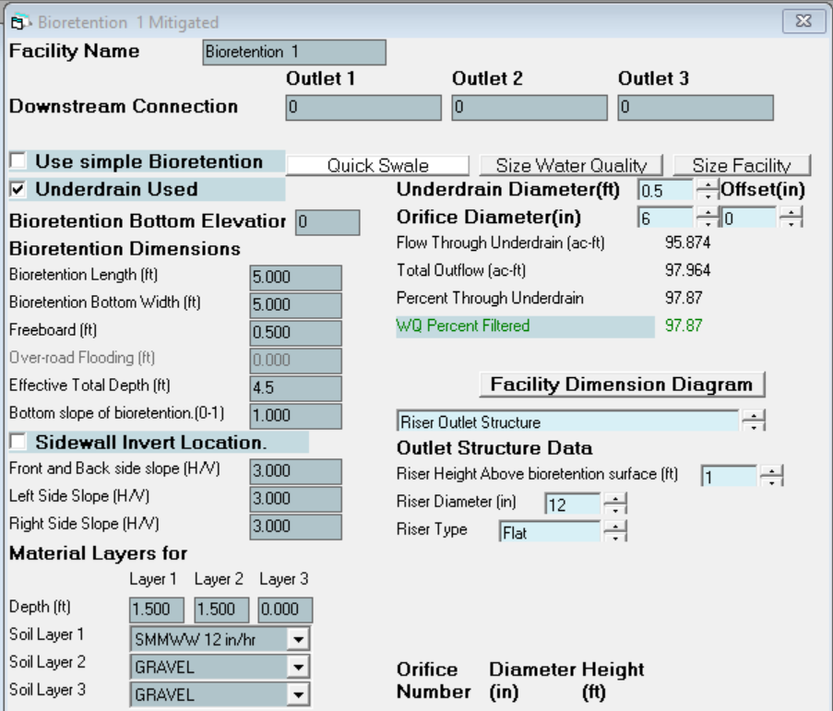
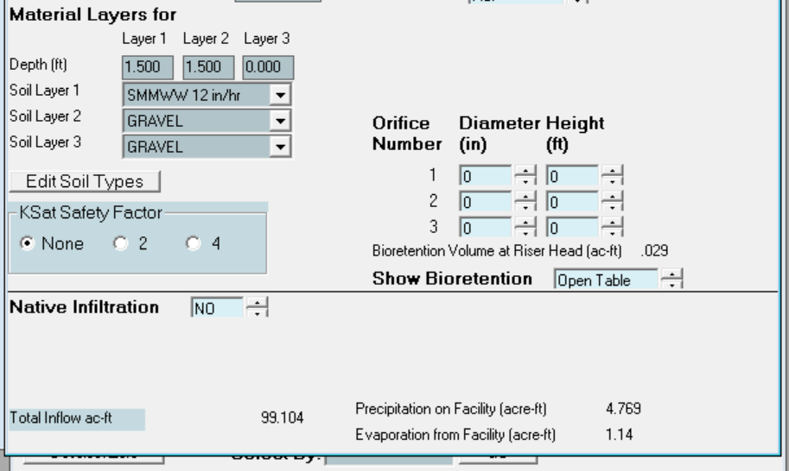

WWHM2012
PROJECT REPORT
___________________________________________________________________

Project Name: Onsite Bioretention Facility
Site Name:
Site Address:
City :
Report Date: 5/18/2021
Gage :
Data Start : 10/01/1901
Data End : 09/30/2059
Precip Scale: 1.00
Version Date: 2019/09/13
Version : 4.2.17
___________________________________________________________________

Low Flow Threshold for POC 1 : 50 Percent of the 2 Year
___________________________________________________________________

High Flow Threshold for POC 1: 50 year
___________________________________________________________________

PREDEVELOPED LAND USE

Name : Basin 1
Bypass: No

GroundWater: No

Pervious Land Use acre
C, Lawn, Mod .0459

Pervious Total 0.0459

Impervious Land Use acre
ROADS FLAT 0.215

Impervious Total 0.215

Basin Total 0.2609

___________________________________________________________________

Element Flows To:
Surface Interflow Groundwater

___________________________________________________________________

MITIGATED LAND USE

Name : Basin 1
Bypass: No

GroundWater: No

Pervious Land Use acre
C, Lawn, Mod .0459

Pervious Total 0.0459

Impervious Land Use acre
ROADS FLAT 0.215

Impervious Total 0.215

Basin Total 0.2609

___________________________________________________________________

Element Flows To:
Surface Interflow Groundwater
Surface retention 1 Surface retention 1
___________________________________________________________________

Name : Bioretention 1
Bottom Length: 5.00 ft.
Bottom Width: 5.00 ft.
Material thickness of first layer: 1.5
Material type for first layer: SMMWW 12 in/hr
Material thickness of second layer: 1.5
Material type for second layer: GRAVEL
Material thickness of third layer: 0
Material type for third layer: GRAVEL
Underdrain used
Underdrain Diameter (feet): 0.5
Orifice Diameter (in.): 6
Offset (in.): 0
Flow Through Underdrain (ac-ft.): 95.874
Total Outflow (ac-ft.): 97.964
Percent Through Underdrain: 97.87
Discharge Structure
Riser Height: 1 ft.
Riser Diameter: 12 in.

Element Flows To:
Outlet 1 Outlet 2

___________________________________________________________________

Bioretention 1 Hydraulic Table
Stage(feet) Area(ac.) Volume(ac-ft.) Discharge(cfs) Infilt(cfs)
0.0000 0.012144 0.000000 0.0000 0.0000
0.0495 0.011936 0.000007 0.0000 0.0000
0.0989 0.011628 0.000015 0.0000 0.0000
0.1484 0.011323 0.000023 0.0000 0.0000
0.1978 0.011022 0.000033 0.0000 0.0000
0.2473 0.010726 0.000043 0.0001 0.0000
0.2967 0.010434 0.000054 0.0001 0.0000
0.3462 0.010145 0.000067 0.0001 0.0000
0.3956 0.009861 0.000080 0.0002 0.0000
0.4451 0.009580 0.000095 0.0002 0.0000
0.4945 0.009304 0.000111 0.0003 0.0000
0.5440 0.009032 0.000128 0.0004 0.0000
0.5934 0.008764 0.000147 0.0005 0.0000
0.6429 0.008500 0.000166 0.0005 0.0000
0.6923 0.008240 0.000187 0.0006 0.0000
0.7418 0.007983 0.000210 0.0007 0.0000
0.7912 0.007731 0.000234 0.0009 0.0000
0.8407 0.007483 0.000259 0.0011 0.0000
0.8901 0.007240 0.000286 0.0011 0.0000
0.9396 0.007000 0.000315 0.0013 0.0000
0.9890 0.006764 0.000345 0.0015 0.0000
1.0385 0.006532 0.000377 0.0017 0.0000
1.0879 0.006304 0.000410 0.0020 0.0000
1.1374 0.006081 0.000446 0.0022 0.0000
1.1868 0.005861 0.000483 0.0022 0.0000
1.2363 0.005645 0.000522 0.0025 0.0000
1.2857 0.005434 0.000563 0.0028 0.0000
1.3352 0.005226 0.000606 0.0032 0.0000
1.3846 0.005022 0.000651 0.0036 0.0000
1.4341 0.004823 0.000698 0.0037 0.0000
1.4835 0.004628 0.000747 0.0039 0.0000
1.5330 0.004436 0.000794 0.0044 0.0000
1.5824 0.004249 0.000842 0.0048 0.0000
1.6319 0.004066 0.000893 0.0053 0.0000
1.6813 0.003886 0.000945 0.0056 0.0000
1.7308 0.003711 0.001000 0.0057 0.0000
1.7802 0.003540 0.001057 0.0063 0.0000
1.8297 0.003373 0.001116 0.0068 0.0000
1.8791 0.003210 0.001177 0.0116 0.0000
1.9286 0.003051 0.001240 0.0116 0.0000
1.9780 0.002896 0.001306 0.0116 0.0000
2.0275 0.002745 0.001375 0.0116 0.0000
2.0769 0.002598 0.001445 0.0116 0.0000
2.1264 0.002455 0.001518 0.0116 0.0000
2.1758 0.002316 0.001594 0.0116 0.0000
2.2253 0.002181 0.001672 0.0116 0.0000
2.2747 0.002050 0.001752 0.0116 0.0000
2.3242 0.001924 0.001836 0.0116 0.0000
2.3736 0.001801 0.001922 0.0116 0.0000
2.4231 0.001682 0.002010 0.0116 0.0000
2.4725 0.001568 0.002101 0.0116 0.0000
2.5220 0.001457 0.002195 0.0116 0.0000
2.5714 0.001351 0.002292 0.0116 0.0000
2.6209 0.001248 0.002392 0.0116 0.0000
2.6703 0.001150 0.002495 0.0116 0.0000
2.7198 0.001055 0.002600 0.0116 0.0000
2.7692 0.000965 0.002709 0.0116 0.0000
2.8187 0.000879 0.002820 0.0116 0.0000
2.8681 0.000796 0.002935 0.0116 0.0000
2.9176 0.000718 0.003053 0.0116 0.0000
2.9670 0.000644 0.003174 0.0116 0.0000
3.0000 0.000574 0.003256 0.0116 0.0000

Surface retention 1 Hydraulic Table
Stage(feet) Area(ac.) Volume(ac-ft.) Discharge(cfs) To Amended(cfs) Wetted Surface
3.0000 0.012144 0.003256 0.0000 0.0069 0.0000
3.0495 0.012460 0.003864 0.0000 0.0069 0.0000
3.0989 0.012779 0.004488 0.0000 0.0074 0.0000
3.1484 0.013102 0.005128 0.0000 0.0076 0.0000
3.1978 0.013430 0.005784 0.0000 0.0079 0.0000
3.2473 0.013761 0.006457 0.0000 0.0081 0.0000
3.2967 0.014097 0.007146 0.0000 0.0083 0.0000
3.3462 0.014436 0.007851 0.0000 0.0085 0.0000
3.3956 0.014780 0.008573 0.0000 0.0088 0.0000
3.4451 0.015128 0.009313 0.0000 0.0090 0.0000
3.4945 0.015479 0.010070 0.0000 0.0092 0.0000
3.5440 0.015835 0.010844 0.0000 0.0095 0.0000
3.5934 0.016195 0.011636 0.0000 0.0097 0.0000
3.6429 0.016559 0.012446 0.0000 0.0099 0.0000
3.6923 0.016927 0.013274 0.0000 0.0101 0.0000
3.7418 0.017299 0.014120 0.0000 0.0104 0.0000
3.7912 0.017675 0.014985 0.0000 0.0106 0.0000
3.8407 0.018055 0.015868 0.0000 0.0108 0.0000
3.8901 0.018439 0.016770 0.0000 0.0111 0.0000
3.9396 0.018827 0.017692 0.0000 0.0113 0.0000
3.9890 0.019219 0.018632 0.0000 0.0115 0.0000
4.0385 0.019615 0.019593 0.0800 0.0118 0.0000
4.0879 0.020015 0.020573 0.2754 0.0120 0.0000
4.1374 0.020420 0.021572 0.5323 0.0122 0.0000
4.1868 0.020828 0.022592 0.8261 0.0124 0.0000
4.2363 0.021240 0.023632 1.1332 0.0127 0.0000
4.2857 0.021657 0.024693 1.4294 0.0129 0.0000
4.3352 0.022077 0.025774 1.6924 0.0131 0.0000
4.3846 0.022502 0.026877 1.9054 0.0134 0.0000
4.4341 0.022930 0.028000 2.0620 0.0136 0.0000
4.4835 0.023363 0.029144 2.1721 0.0138 0.0000
4.5000 0.023508 0.029531 2.2994 0.0139 0.0000
___________________________________________________________________

Name : Surface retention 1

Element Flows To:
Outlet 1 Outlet 2
Bioretention 1
___________________________________________________________________

___________________________________________________________________

ANALYSIS RESULTS

Stream Protection Duration

___________________________________________________________________

Predeveloped Landuse Totals for POC #1
Total Pervious Area:0.0459
Total Impervious Area:0.215
___________________________________________________________________

Mitigated Landuse Totals for POC #1
Total Pervious Area:0.0459
Total Impervious Area:0.215
___________________________________________________________________

Flow Frequency Return Periods for Predeveloped. POC #1
Return Period Flow(cfs)
2 year 0.077441
5 year 0.104792
10 year 0.124796
25 year 0.152311
50 year 0.174492
100 year 0.198164

Flow Frequency Return Periods for Mitigated. POC #1
Return Period Flow(cfs)
2 year 0.032388
5 year 0.062528
10 year 0.086885
25 year 0.122038
50 year 0.151079
100 year 0.182333
___________________________________________________________________

Stream Protection Duration
Annual Peaks for Predeveloped and Mitigated. POC #1
Year Predeveloped Mitigated
1902 0.089 0.056
1903 0.099 0.011
1904 0.121 0.049
1905 0.051 0.037
1906 0.056 0.011
1907 0.079 0.079
1908 0.063 0.038
1909 0.076 0.032
1910 0.074 0.077
1911 0.085 0.024
1912 0.152 0.133
1913 0.059 0.034
1914 0.261 0.041
1915 0.052 0.011
1916 0.095 0.055
1917 0.036 0.011
1918 0.076 0.035
1919 0.048 0.011
1920 0.065 0.028
1921 0.055 0.034
1922 0.089 0.059
1923 0.060 0.039
1924 0.110 0.020
1925 0.047 0.011
1926 0.089 0.046
1927 0.073 0.027
1928 0.056 0.011
1929 0.112 0.068
1930 0.113 0.011
1931 0.056 0.041
1932 0.060 0.041
1933 0.059 0.057
1934 0.102 0.085
1935 0.050 0.011
1936 0.072 0.011
1937 0.104 0.086
1938 0.052 0.026
1939 0.065 0.011
1940 0.114 0.055
1941 0.112 0.010
1942 0.089 0.063
1943 0.086 0.028
1944 0.126 0.120
1945 0.092 0.052
1946 0.074 0.011
1947 0.055 0.030
1948 0.077 0.068
1949 0.117 0.071
1950 0.066 0.011
1951 0.100 0.010
1952 0.125 0.125
1953 0.114 0.119
1954 0.063 0.021
1955 0.057 0.011
1956 0.056 0.009
1957 0.062 0.037
1958 0.080 0.077
1959 0.081 0.049
1960 0.061 0.011
1961 0.179 0.065
1962 0.075 0.046
1963 0.055 0.011
1964 0.170 0.031
1965 0.074 0.068
1966 0.061 0.019
1967 0.089 0.011
1968 0.072 0.035
1969 0.065 0.035
1970 0.076 0.047
1971 0.074 0.067
1972 0.247 0.083
1973 0.134 0.075
1974 0.100 0.040
1975 0.111 0.089
1976 0.115 0.063
1977 0.046 0.011
1978 0.084 0.085
1979 0.084 0.010
1980 0.084 0.011
1981 0.077 0.026
1982 0.063 0.011
1983 0.087 0.057
1984 0.087 0.042
1985 0.101 0.032
1986 0.050 0.014
1987 0.084 0.073
1988 0.051 0.039
1989 0.047 0.033
1990 0.063 0.034
1991 0.094 0.061
1992 0.086 0.072
1993 0.099 0.038
1994 0.071 0.053
1995 0.053 0.010
1996 0.074 0.063
1997 0.065 0.011
1998 0.079 0.074
1999 0.081 0.010
2000 0.073 0.011
2001 0.057 0.011
2002 0.114 0.033
2003 0.062 0.054
2004 0.092 0.056
2005 0.177 0.011
2006 0.082 0.010
2007 0.094 0.091
2008 0.077 0.027
2009 0.057 0.013
2010 0.075 0.065
2011 0.077 0.010
2012 0.074 0.071
2013 0.071 0.022
2014 0.066 0.010
2015 0.120 0.048
2016 0.069 0.010
2017 0.112 0.117
2018 0.072 0.074
2019 0.108 0.104
2020 0.085 0.011
2021 0.070 0.065
2022 0.117 0.011
2023 0.142 0.033
2024 0.167 0.124
2025 0.074 0.035
2026 0.082 0.058
2027 0.091 0.030
2028 0.036 0.010
2029 0.060 0.033
2030 0.117 0.076
2031 0.037 0.011
2032 0.062 0.009
2033 0.078 0.010
2034 0.061 0.040
2035 0.081 0.079
2036 0.061 0.052
2037 0.082 0.011
2038 0.084 0.081
2039 0.157 0.010
2040 0.063 0.046
2041 0.080 0.020
2042 0.090 0.082
2043 0.099 0.060
2044 0.070 0.049
2045 0.057 0.022
2046 0.063 0.040
2047 0.076 0.011
2048 0.062 0.062
2049 0.093 0.065
2050 0.071 0.031
2051 0.103 0.105
2052 0.074 0.044
2053 0.063 0.048
2054 0.137 0.080
2055 0.077 0.011
2056 0.099 0.011
2057 0.049 0.029
2058 0.093 0.017
2059 0.116 0.070
___________________________________________________________________

Stream Protection Duration
Ranked Annual Peaks for Predeveloped and Mitigated. POC #1
Rank Predeveloped Mitigated
1 0.2606 0.1333
2 0.2470 0.1248
3 0.1793 0.1244
4 0.1765 0.1195
5 0.1696 0.1194
6 0.1669 0.1170
7 0.1568 0.1050
8 0.1516 0.1040
9 0.1423 0.0908
10 0.1370 0.0886
11 0.1342 0.0856
12 0.1258 0.0851
13 0.1246 0.0847
14 0.1210 0.0829
15 0.1201 0.0819
16 0.1173 0.0807
17 0.1170 0.0805
18 0.1170 0.0791
19 0.1159 0.0788
20 0.1146 0.0774
21 0.1144 0.0765
22 0.1137 0.0761
23 0.1135 0.0750
24 0.1134 0.0739
25 0.1122 0.0737
26 0.1120 0.0729
27 0.1119 0.0725
28 0.1106 0.0713
29 0.1101 0.0711
30 0.1079 0.0702
31 0.1043 0.0684
32 0.1035 0.0680
33 0.1022 0.0678
34 0.1013 0.0666
35 0.1001 0.0654
36 0.0999 0.0652
37 0.0994 0.0646
38 0.0992 0.0646
39 0.0990 0.0634
40 0.0985 0.0631
41 0.0951 0.0628
42 0.0944 0.0621
43 0.0942 0.0614
44 0.0929 0.0601
45 0.0926 0.0589
46 0.0924 0.0577
47 0.0920 0.0572
48 0.0908 0.0569
49 0.0898 0.0558
50 0.0894 0.0557
51 0.0893 0.0553
52 0.0892 0.0552
53 0.0890 0.0538
54 0.0887 0.0530
55 0.0871 0.0517
56 0.0868 0.0516
57 0.0861 0.0493
58 0.0855 0.0488
59 0.0849 0.0487
60 0.0848 0.0484
61 0.0844 0.0479
62 0.0841 0.0466
63 0.0840 0.0463
64 0.0839 0.0461
65 0.0836 0.0460
66 0.0821 0.0443
67 0.0819 0.0416
68 0.0817 0.0414
69 0.0812 0.0412
70 0.0811 0.0406
71 0.0805 0.0403
72 0.0803 0.0400
73 0.0797 0.0400
74 0.0794 0.0391
75 0.0787 0.0386
76 0.0781 0.0381
77 0.0775 0.0380
78 0.0772 0.0373
79 0.0767 0.0368
80 0.0766 0.0351
81 0.0765 0.0350
82 0.0763 0.0349
83 0.0761 0.0347
84 0.0760 0.0344
85 0.0755 0.0336
86 0.0750 0.0335
87 0.0749 0.0333
88 0.0744 0.0332
89 0.0743 0.0331
90 0.0742 0.0328
91 0.0742 0.0317
92 0.0741 0.0316
93 0.0740 0.0315
94 0.0737 0.0306
95 0.0737 0.0304
96 0.0734 0.0299
97 0.0730 0.0294
98 0.0721 0.0277
99 0.0721 0.0276
100 0.0721 0.0273
101 0.0714 0.0266
102 0.0712 0.0258
103 0.0710 0.0256
104 0.0702 0.0238
105 0.0698 0.0221
106 0.0689 0.0218
107 0.0660 0.0210
108 0.0656 0.0200
109 0.0653 0.0199
110 0.0652 0.0194
111 0.0646 0.0167
112 0.0645 0.0137
113 0.0635 0.0135
114 0.0632 0.0115
115 0.0631 0.0114
116 0.0631 0.0114
117 0.0630 0.0113
118 0.0626 0.0113
119 0.0626 0.0113
120 0.0623 0.0113
121 0.0623 0.0113
122 0.0622 0.0112
123 0.0619 0.0111
124 0.0611 0.0111
125 0.0611 0.0111
126 0.0608 0.0111
127 0.0606 0.0111
128 0.0605 0.0110
129 0.0605 0.0109
130 0.0604 0.0109
131 0.0593 0.0109
132 0.0591 0.0109
133 0.0574 0.0109
134 0.0572 0.0108
135 0.0571 0.0108
136 0.0568 0.0108
137 0.0563 0.0108
138 0.0562 0.0108
139 0.0559 0.0108
140 0.0556 0.0107
141 0.0555 0.0107
142 0.0553 0.0106
143 0.0547 0.0105
144 0.0535 0.0105
145 0.0519 0.0105
146 0.0516 0.0103
147 0.0513 0.0103
148 0.0509 0.0102
149 0.0501 0.0101
150 0.0497 0.0101
151 0.0485 0.0100
152 0.0479 0.0099
153 0.0469 0.0099
154 0.0468 0.0098
155 0.0464 0.0098
156 0.0373 0.0098
157 0.0358 0.0094
158 0.0355 0.0094
___________________________________________________________________

Stream Protection Duration
POC #1
The Facility PASSED

The Facility PASSED.

Flow(cfs) Predev Mit Percentage Pass/Fail
0.0387 4618 1105 23 Pass
0.0401 4072 1012 24 Pass
0.0415 3559 932 26 Pass
0.0428 3165 869 27 Pass
0.0442 2830 795 28 Pass
0.0456 2532 726 28 Pass
0.0469 2264 665 29 Pass
0.0483 2035 608 29 Pass
0.0497 1833 562 30 Pass
0.0511 1652 519 31 Pass
0.0524 1481 475 32 Pass
0.0538 1337 439 32 Pass
0.0552 1211 402 33 Pass
0.0565 1093 363 33 Pass
0.0579 999 332 33 Pass
0.0593 913 305 33 Pass
0.0607 825 275 33 Pass
0.0620 755 254 33 Pass
0.0634 693 231 33 Pass
0.0648 627 211 33 Pass
0.0661 573 188 32 Pass
0.0675 535 174 32 Pass
0.0689 478 158 33 Pass
0.0703 444 148 33 Pass
0.0716 401 134 33 Pass
0.0730 366 125 34 Pass
0.0744 335 109 32 Pass
0.0757 312 97 31 Pass
0.0771 276 84 30 Pass
0.0785 254 75 29 Pass
0.0799 231 68 29 Pass
0.0812 212 61 28 Pass
0.0826 197 55 27 Pass
0.0840 177 51 28 Pass
0.0853 168 46 27 Pass
0.0867 153 41 26 Pass
0.0881 142 38 26 Pass
0.0895 126 35 27 Pass
0.0908 118 33 27 Pass
0.0922 112 29 25 Pass
0.0936 107 27 25 Pass
0.0949 102 26 25 Pass
0.0963 98 25 25 Pass
0.0977 89 23 25 Pass
0.0991 81 21 25 Pass
0.1004 75 21 28 Pass
0.1018 74 20 27 Pass
0.1032 68 20 29 Pass
0.1045 64 19 29 Pass
0.1059 58 16 27 Pass
0.1073 57 14 24 Pass
0.1087 55 13 23 Pass
0.1100 55 12 21 Pass
0.1114 53 10 18 Pass
0.1128 50 10 20 Pass
0.1141 46 10 21 Pass
0.1155 41 9 21 Pass
0.1169 39 7 17 Pass
0.1183 36 6 16 Pass
0.1196 34 3 8 Pass
0.1210 32 3 9 Pass
0.1224 31 3 9 Pass
0.1237 31 3 9 Pass
0.1251 29 1 3 Pass
0.1265 27 1 3 Pass
0.1279 27 1 3 Pass
0.1292 26 1 3 Pass
0.1306 26 1 3 Pass
0.1320 26 1 3 Pass
0.1333 23 1 4 Pass
0.1347 22 0 0 Pass
0.1361 22 0 0 Pass
0.1375 21 0 0 Pass
0.1388 21 0 0 Pass
0.1402 21 0 0 Pass
0.1416 20 0 0 Pass
0.1429 18 0 0 Pass
0.1443 17 0 0 Pass
0.1457 17 0 0 Pass
0.1471 17 0 0 Pass
0.1484 16 0 0 Pass
0.1498 16 0 0 Pass
0.1512 15 0 0 Pass
0.1525 14 0 0 Pass
0.1539 14 0 0 Pass
0.1553 14 0 0 Pass
0.1567 13 0 0 Pass
0.1580 12 0 0 Pass
0.1594 12 0 0 Pass
0.1608 12 0 0 Pass
0.1621 12 0 0 Pass
0.1635 12 0 0 Pass
0.1649 11 0 0 Pass
0.1663 11 0 0 Pass
0.1676 10 0 0 Pass
0.1690 10 0 0 Pass
0.1704 9 0 0 Pass
0.1717 8 0 0 Pass
0.1731 7 0 0 Pass
0.1745 7 0 0 Pass
_____________________________________________________

___________________________________________________________________

Water Quality BMP Flow and Volume for POC #1
On-line facility volume: 0.0078 acre-feet
On-line facility target flow: 0.0108 cfs.
Adjusted for 15 min: 0.0108 cfs.
Off-line facility target flow: 0.0062 cfs.
Adjusted for 15 min: 0.0062 cfs.
___________________________________________________________________

LID Report

LID Technique Used for Total Volume Volume Infiltration Cumulative Percent Water Quality Percent Comment
Treatment? Needs Through Volume Volume Volume Water Quality
Treatment Facility (ac-ft.) Infiltration Infiltrated Treated
(ac-ft) (ac-ft) Credit
retention 1 POC N 89.15 N 0.00
Total Volume Infiltrated 89.15 0.00 0.00 0.00 0.00 0% No Treat. Credit
Compliance with LID Standard 8 Duration Analysis Result = Failed

___________________________________________________________________

Perlnd and Implnd Changes
No changes have been made.
___________________________________________________________________

This program and accompanying documentation are provided 'as-is' without warranty of any kind. The entire risk regarding the performance and results of this program is assumed by End User. Clear Creek Solutions Inc. and the governmental licensee or sublicensees disclaim all warranties, either expressed or implied, including but not limited to implied warranties of program and accompanying documentation. In no event shall Clear Creek Solutions Inc. be liable for any damages whatsoever (including without limitation to damages for loss of business profits, loss of business information, business interruption, and the like) arising out of the use of, or inability to use this program even if Clear Creek Solutions Inc. or their authorized representatives have been advised of the possibility of such damages. Software Copyright © by : Clear Creek Solutions, Inc. 2005-2021; All Rights Reserved.

Conveyance System Design

The model shows that the system can accommodate the 25-year storm event with 0.5 feet of freeboard between top of water surface elevation and top of structure. A 25-year storm event of 3.5 inches was used. A tailwater elevation of 100.9 was chosen which is 90% full at the connection to the City system.

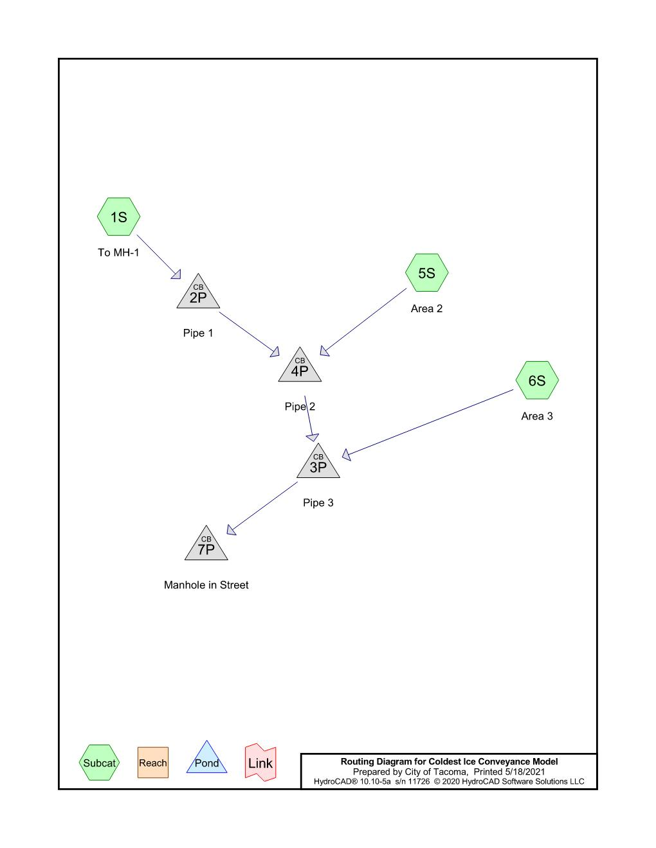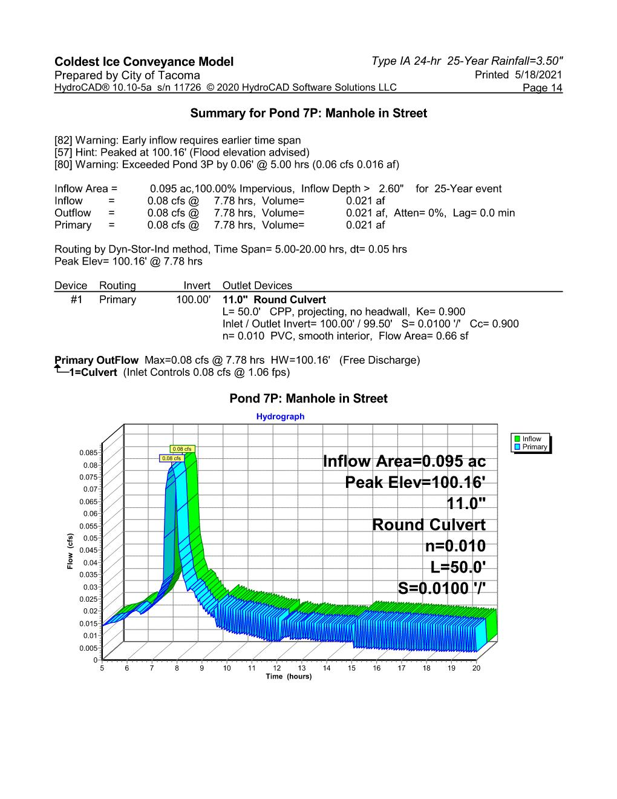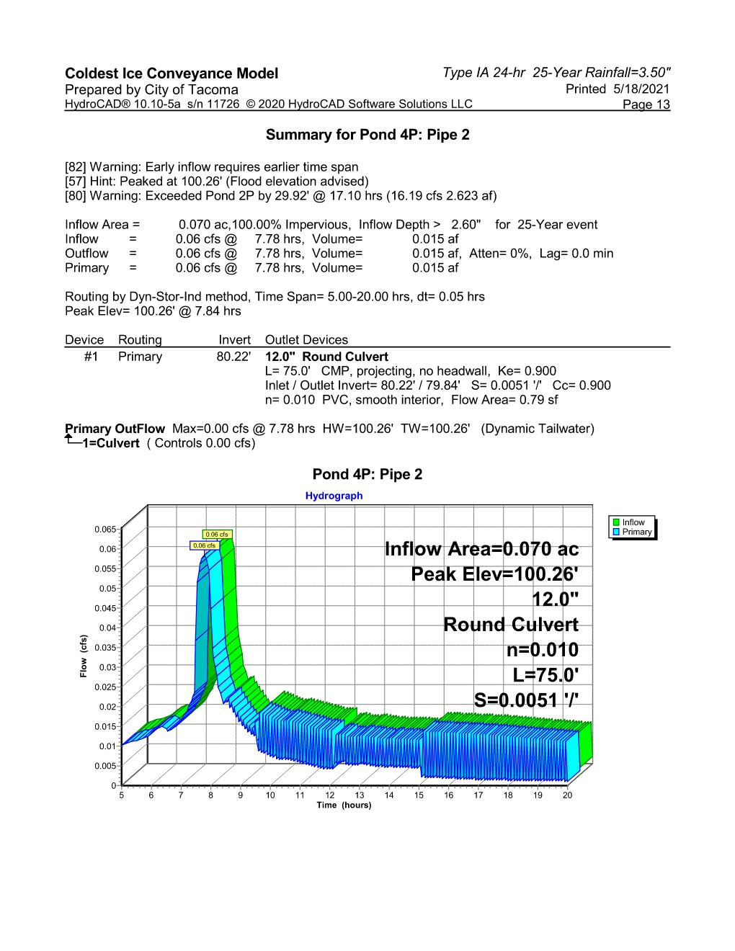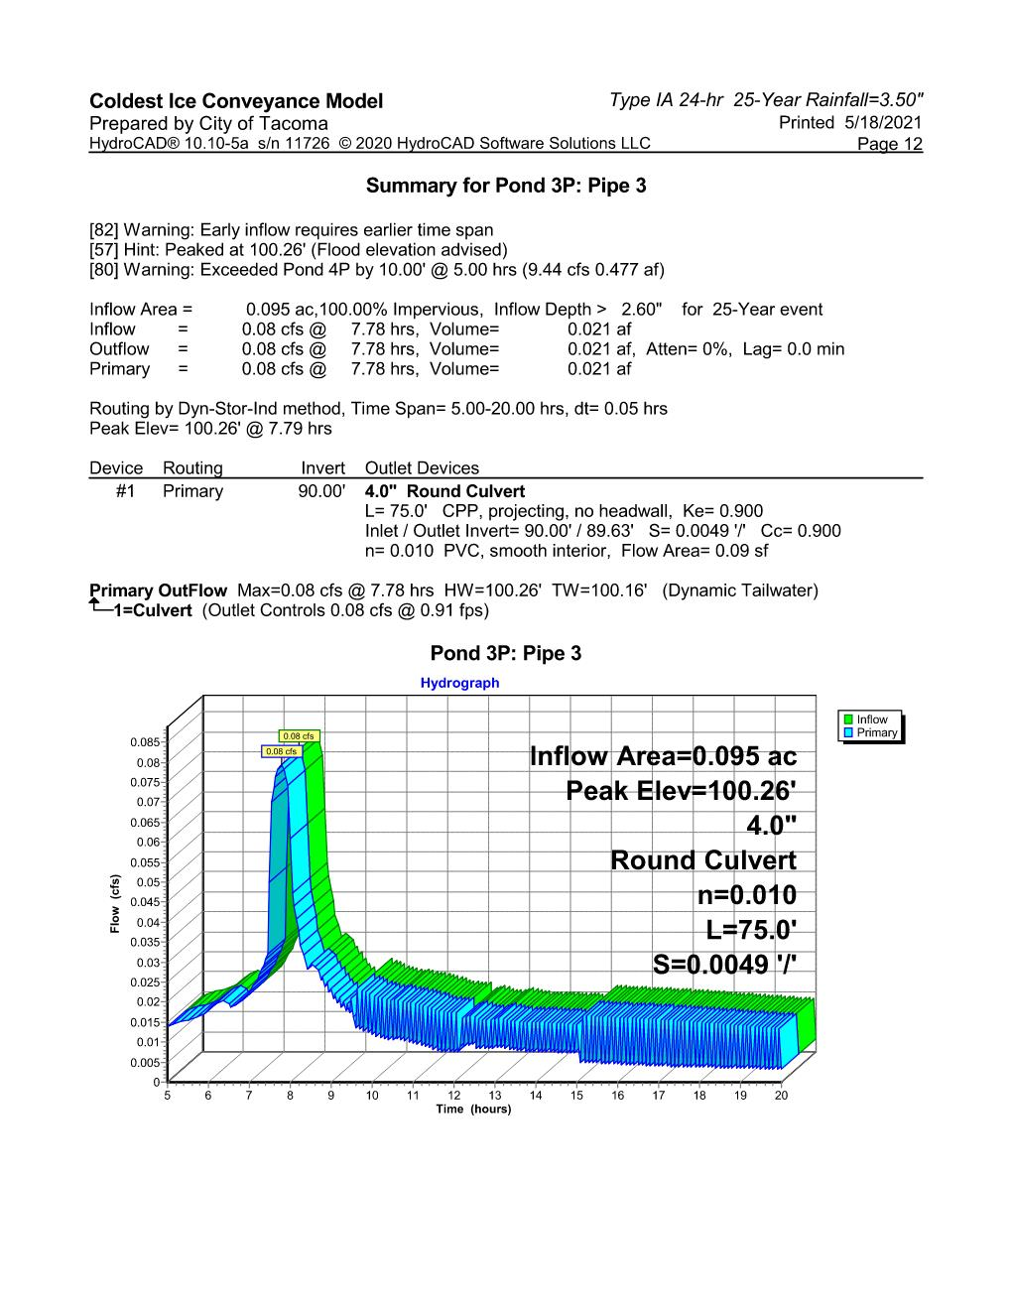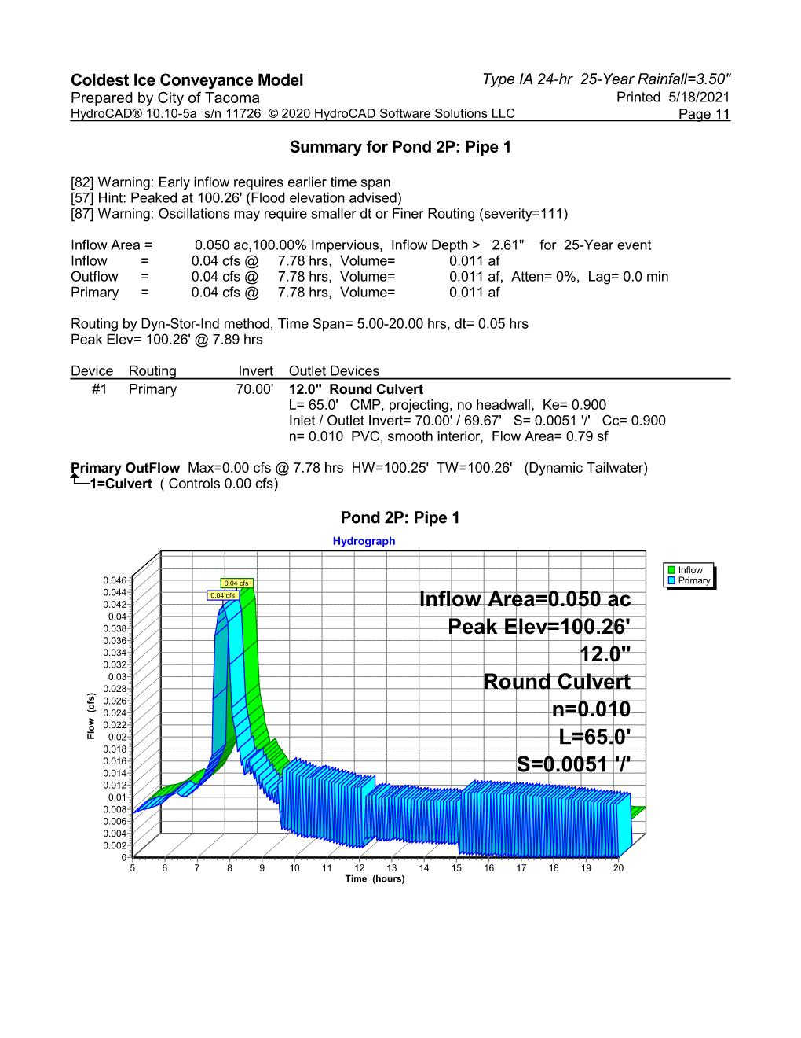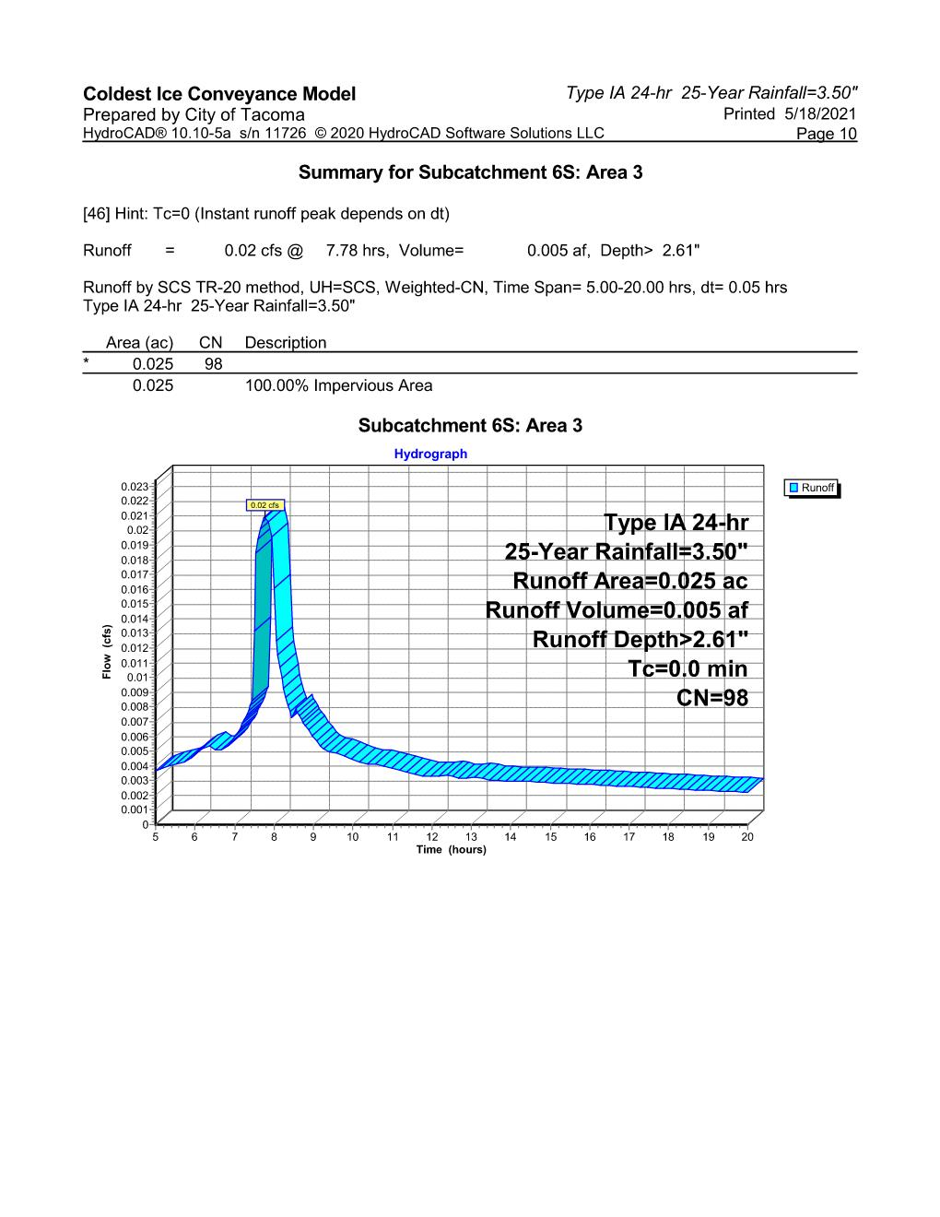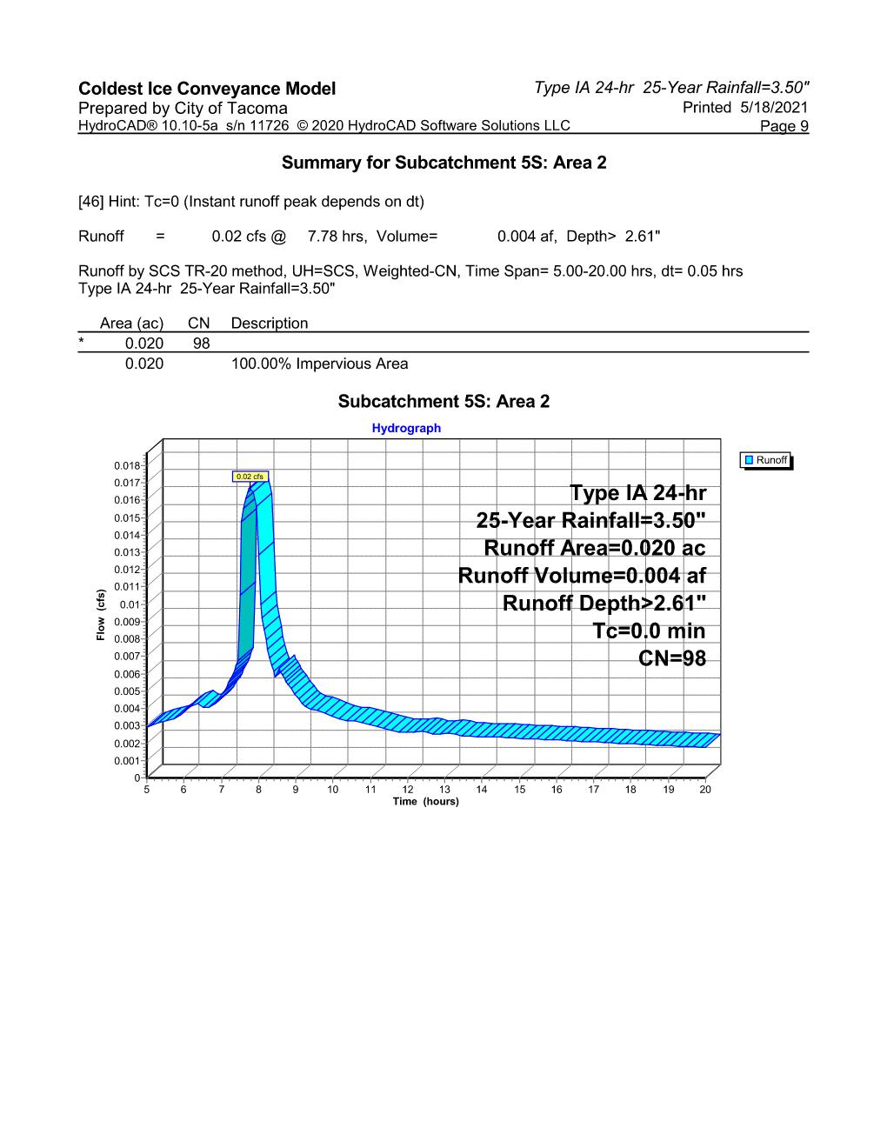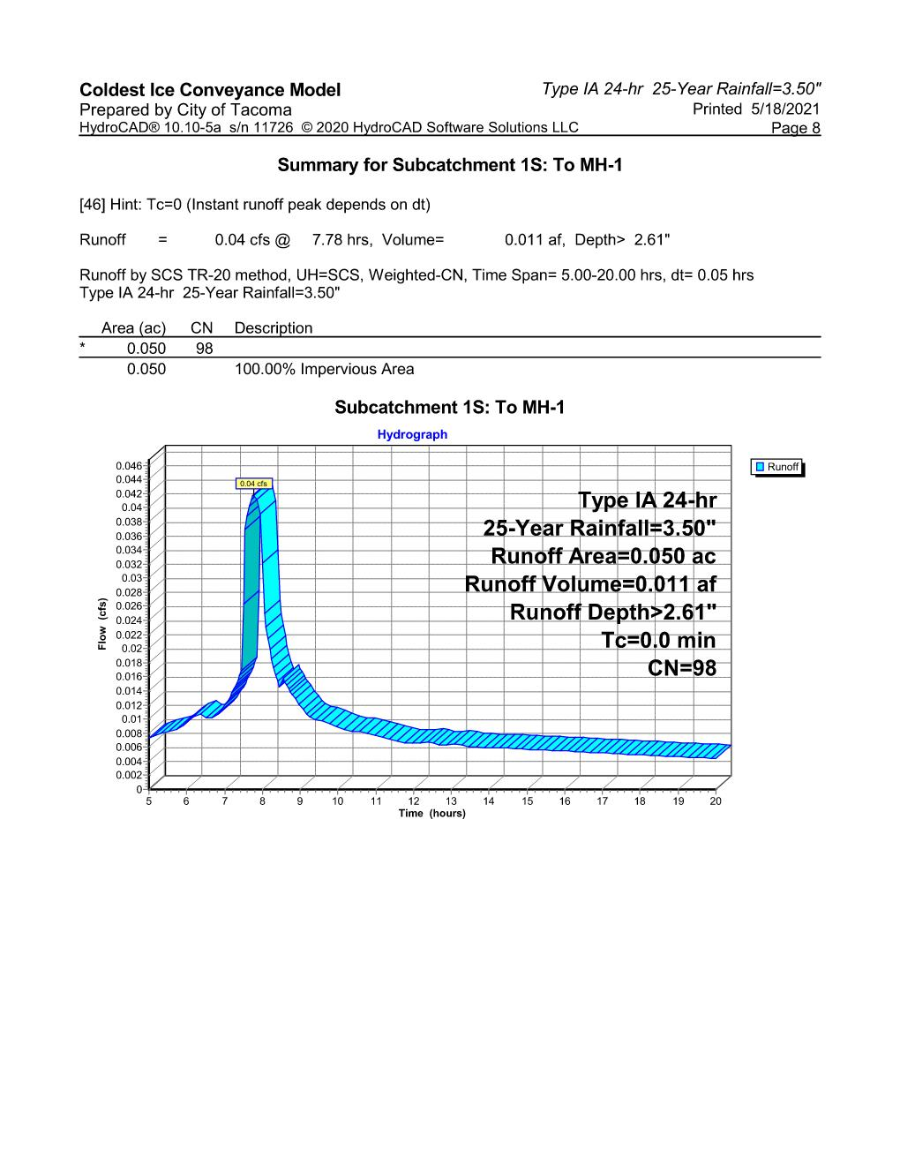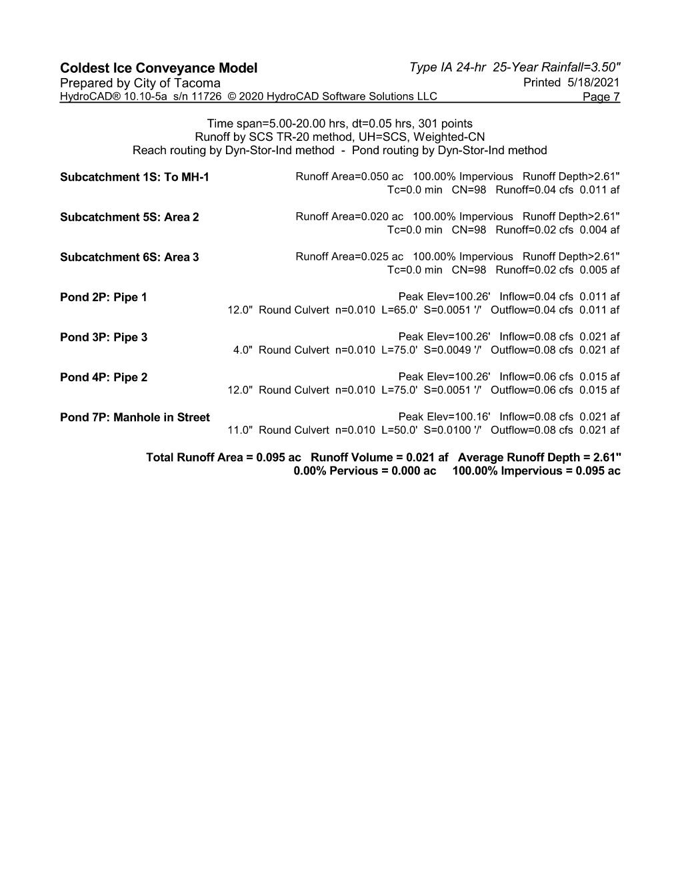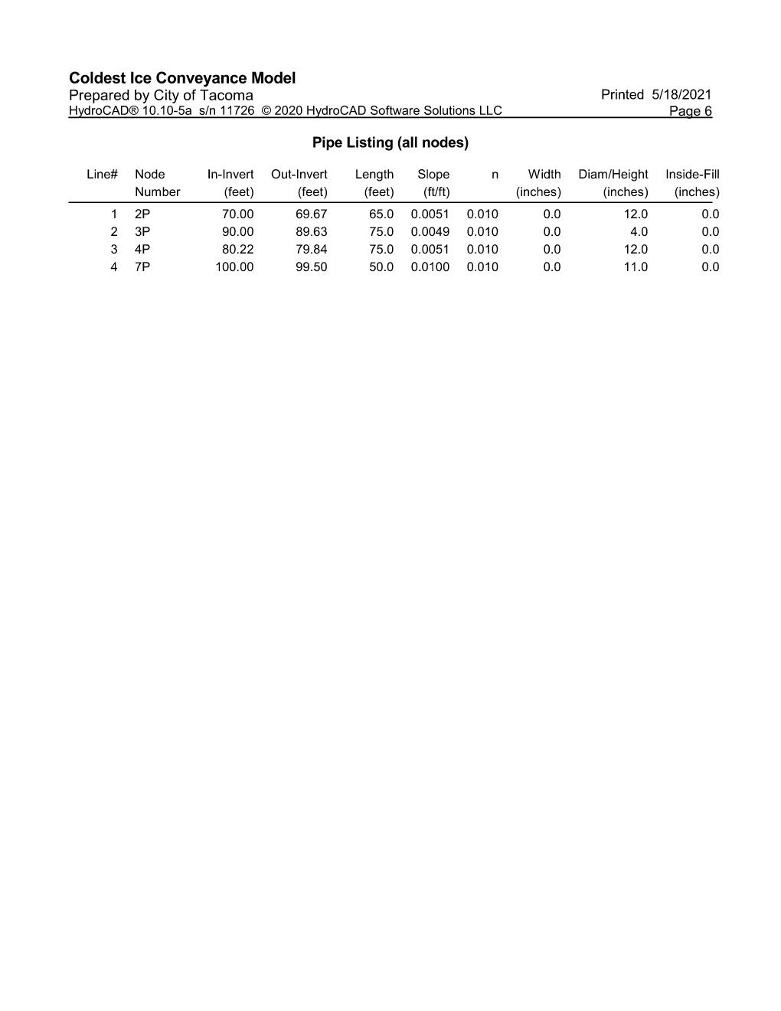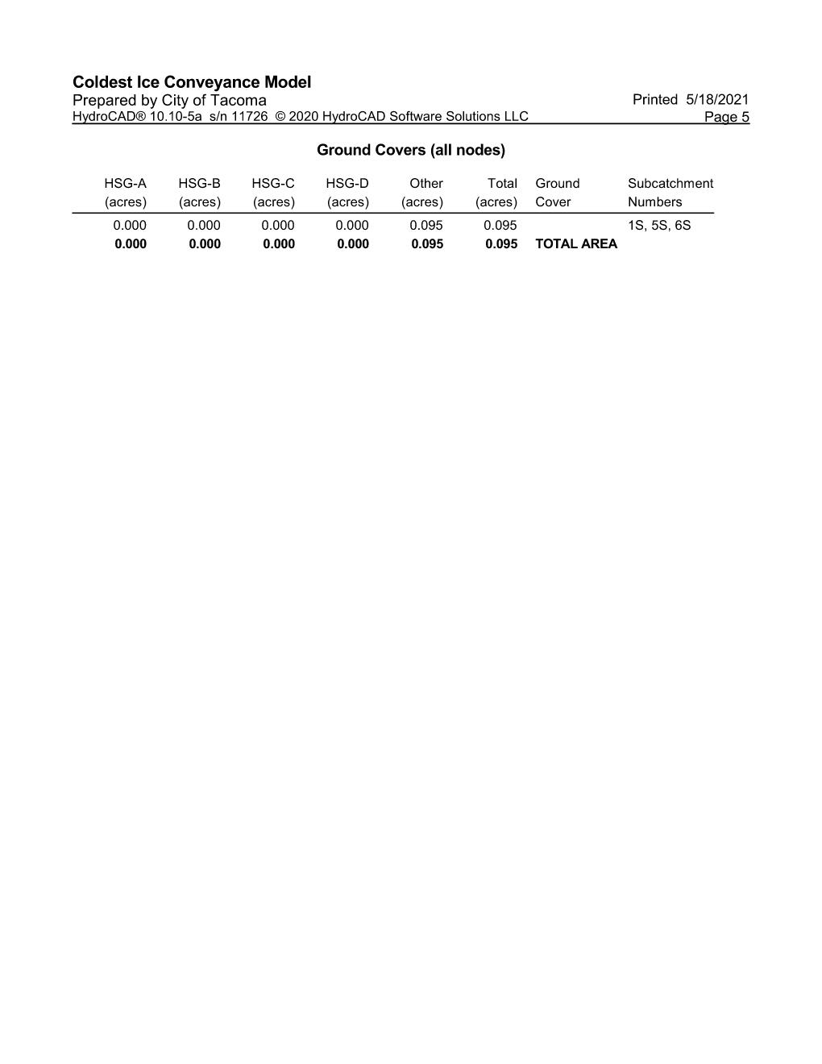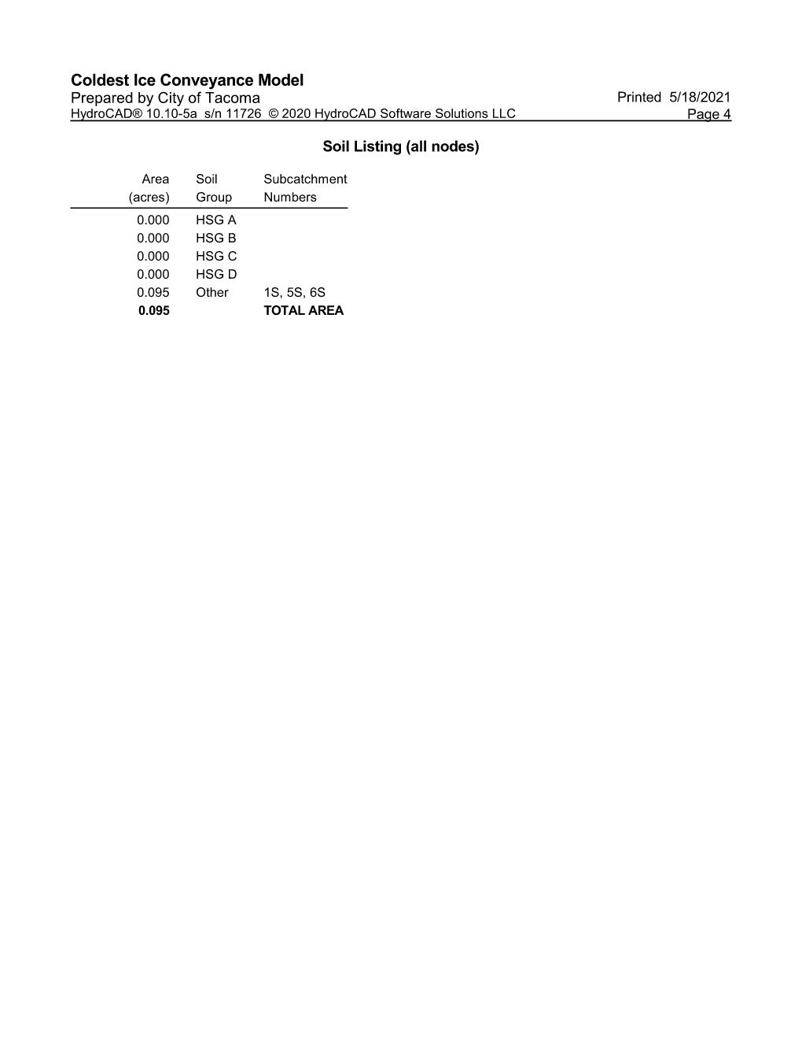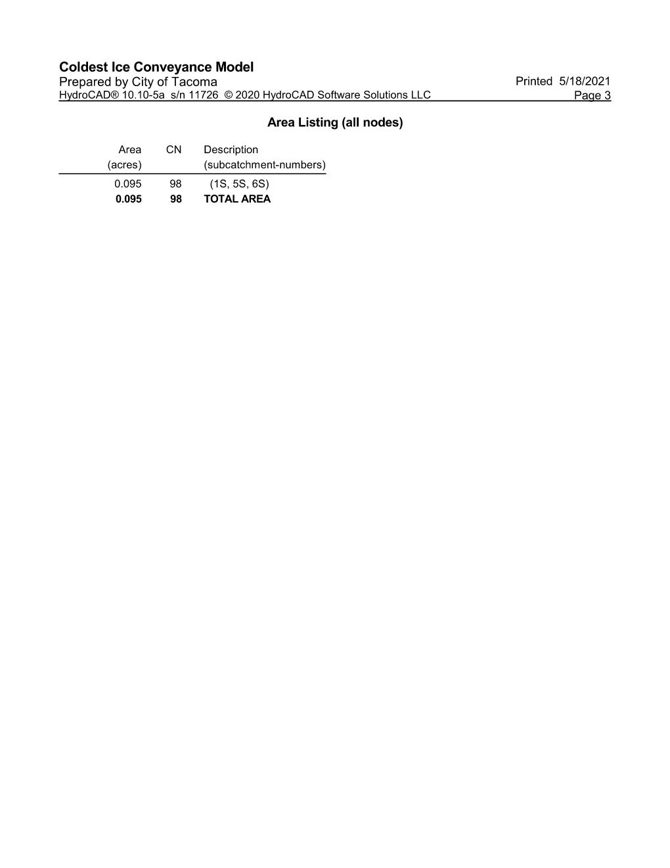

Emerging Technology Use Level Designations

See next page.
